ECE/COE 1896

Senior Design

Robotic Blackjack Dealer Final Document

Team #7

Prepared By: Kyle Cullen

Nicholas Lowe

Curtis Maher

Luca Mahoney

# Table of Contents

Table of Contents **1**

Table of Figures **3**

Table of Tables **4**

1. Introduction **1**

2. Background **1**

3. System Requirements **4**

3.1 Functional Requirements 4

3.1.1 Physical Requirements 4

3.1.1.1 Dimensions 4

3.1.1.2 Card Movement 4

3.1.1.3 Speed and Timing 4

3.1.1.4 Vacuum Generation 4

3.1.2 Electrical Requirements 5

3.1.2.1 Motors/Motor Driver 5

3.1.2.2 Control Modules 5

3.1.3 Software Requirements 5

3.1.3.1 Device Compatibility 5

3.1.3.2 Program Language 5

3.1.3.3 Betting 5

3.1.3.4 Image Processing 5

3.1.3.5 Player Input 6

3.1.3.6 Game Output 6

3.1.3.7 Interfacing 6

3.2 Game Rules 6

3.2.1 Card Values 6

3.2.2 Starting 6

3.2.3 Playing 6

3.2.4 Player Winning 7

3.2.5 Dealer Winning 7

3.2.6 Betting 7

**4. Design Constraints: Standards and Impacts** **7**

4.1 Industry or Government Standards 7

4.2 Impacts in Non-Technical Contexts 8

4.2.1 Global, Cultural and Societal 8

4.2.2 Legal Limitations 8

**5. Design Summary** **8**

5.1 Hardware 8

5.1.1 Primary Mechanism 8

5.1.2 Vacuum Pump 10

5.1.3 Power Supply 11

5.1.4 Motors and Drivers 14

5.1.5 Flipping Mechanism 14

5.1.6 Control Modules 15

5.1.7 Computer Vision 17

5.1.8 Hardware Input/Output 17

5.2 Software 17

5.2.1 Image Processing 17

5.2.2 Backend Game Logic 21

5.2.3 User Interface 23

5.2.4 Motor Control 23

**6. Team** **25**

6.1 Kyle Cullen 25

6.1.1 Skills learned in ECE coursework 25

6.1.2 Skills learned outside ECE coursework 25

6.2 Nicholas Lowe 26

6.2.1 Skills learned in ECE coursework 26

6.2.2 Skills learned outside ECE coursework 26

6.3 Curtis Maher 27

6.3.1 Skills learned in ECE coursework 27

6.3.2 Skills learned outside ECE coursework 27

6.4 Luca Mahoney 28

6.4.1 Skills learned in ECE coursework 28

6.4.2 Skills learned outside ECE coursework 28

7. Schedule and Budget **29**

7.1 Project Schedule 29

7.2 Project Budget 31

8. System Test and Verification **32**

8.1 Test Plan 32

8.1.1 Software Systems 32

8.1.1.1 Game Logic Test Plan 32

8.1.1.2 Computer Vision Test Plan 32

8.1.2 Hardware Systems 33

8.1.2.1 Power Supply Test Plan 33

8.1.2.2 Gantry System Test Plan 34

8.2 Executed Tests 35

8.2.1 Software Systems 35

8.2.1.1 Game Logic 35

8.2.1.2 Computer Vision 36

8.2.2 Hardware Systems 37

8.2.2.1 Power Supply 37

8.2.2.2 Gantry System 39

**9. New Skills and Learning Strategies** **41**

9.1 Kyle Cullen 41

9.2 Nicholas Lowe 41

9.3 Curtis Maher 42

9.4 Luca Mahoney 42

**10. Conclusions and Future Work** **43**

10.1.1 Planned Minimum Design 43

10.1.2 Actual Design 43

10.1.3 Improvements and Design Changes 43

43

**References** **44**

[To update the Table of Contents, Table of Figures, or Table of Tables, click on any text within the table. Press the F9 key on your keyboard (or right click and select “Update Field”). Then select “Update entire table” from the pop-up window and click “OK”. If you use the formatting styles as directed below, your tables will fill automatically and have the correct page numbers.]

# Table of Figures

Figure 1: Yaskawa Motoman Robotics’ Robotic Blackjack Dealer 3

Figure 2: Gantry (top view)9

Figure 3: Gantry (side view) 9

Figure 4: Force Calculations for Card Lifting 10

Figure 5: Vacuum Pump Utilized in Design 10

Figure 6: Gantry mount for Z-motion and vacuum mechanism 11

Figure 7: Transformer to be Used for the Design 11

Figure 8: Wall Plug Connection Attached to the Primary Side of the Transformer’s Lines 11

Figure 9: Schematic of the Transformer’s Design 11

Figure 10: Waveforms of the Open Load Conditions of the Transformer. 12

Figure 11: Waveforms of the Open Load Conditions of the Transformer. 12

Figure 12: LTSpice Schematic of L-section Filter 12

Figure 13: Ripple Factor Calculations 13

Figure 14: Lowest LC Value Required to have a Ripple Output of less than 2% 13

Figure 15: Flowchart for Project’s Electrical Connections 13

Figure 16: CNC Shield with one DRV8825 Motor Controller 14

Figure 17: Flipping Mechanism 15

Figure 18: Raspberry PI 4 Model B Board 15

Figure 19: Arduino Uno Unit 16

Figure 20: Fully integrated schematic for the power supply. 16

Figure 21: Fully integrated PCB 17

Figure 22: Image Processing Flowchart 18

Figure 23: Ace of Spades; Pic and Contour 19

Figure 24: King of Clubs; Cropped Pic and Contours 20

Figure 25: Ace of Spades; Pic and Contour 21

Figure 26: Game Logic Flowchart for a Game of Blackjack 22

Figure 27: Flowchart for dealing a card with integration 22

Figure 28: Example UI screens through a game 23

Figure 29: Grbl Controller v3.6.1 24

Figure 30: Output ripple of power supply 38

Figure 31: Transient response of motors on power supply 39

Figure 32: Voltage and currents throughout the fully integrated system 39

# Table of Tables

Table 1: Fund Allocation 31

Table 2: Function unit testing results35

Table 3: Card movement error40

Table 4: Timing test results 40

# Introduction

This Robotic Blackjack Dealer project will be designed to provide users with an interactive experience of playing Blackjack that combines the tangibility of playing in real life with the ease of automation found in online games.

The goal of this project will be to design a robotic system that can function as an effective card dealer at a Blackjack table. Currently, live-human dealers are costly for casinos to employ, and hiring enough dealers to fill tables at a casino may increase this cost. Players may also feel uncomfortable with an experienced dealer possibly manipulating the cards to give the house a favorable advantage in the game. Replacing live dealers with robotic dealers will cut on the casinos expenses, allow for more players to be hosted, and will allow for a better established trust that there is no cheating or manipulation

Our design takes influence from 3D printers and a common method with which they navigate a plane. We’ll have a gantry setup that is fixed on a table top and covers an x-y plane. Within the center arm of the gantry, will be a vertically mounted component that can move along the z-axis with a vacuum pump to enable the picking up and movement of cards around the table. Beneath the table will be a camera and connected Raspberry Pi, with the camera looking vertically through a piece of clear acrylic. Also connected to the Pi will be a touchscreen display to enable player interactivity, as well as an Arduino Uno which will handle commands from the Pi and output controls to the motors driving the system.

The final product will function as a blackjack dealer that could easily replace a human at a table. The system’s hardware will include a device that can function as an “arm” and will move a “hand” to move cards around the table. To know what cards are being played, the system’s camera can take a picture of cards as they are being dealt. With this input, the software side of the system will interpret the current state of the game and then prompt the player(s) for their input, which would then further continue the flow of the game’s algorithm. The game as a whole will follow a standard Blackjack ruleset and will incorporate the ability to have multiple players, each able to place bets.

# Background

Blackjack (also known as 21 and pontoon) is a card game played around the world. While its origin is disputed and house rules vary, the general concept of the game remains the same: try to get your hand closer to 21 than the dealer without going over 21. You can add cards to your initial hand of two by requesting a ‘hit’ from the dealer and can choose to ‘stand’ once you feel confident that your hand can win, given that you do so before you go over 21 (‘bust’). This simple concept has stood the test of time as a fun and engaging game of chance and is still a staple in the gambling world to this day.

Blackjack utilizes the standard deck of playing cards, which consists of 52 unique cards. There are 13 different card values, 9 of which are numbered 2-10, respectively. There are 3 face cards: the Jack, the Queen, and the King. Finally, there is the Ace, which typically takes on unique roles in card games, as it can either represent 1 or 11. Each card also has a specified suit, which include hearts, diamonds, spades, and clubs. Hearts and diamonds are typically colored red, with black as the primary color for clubs and spades. There are 4 cards each for the 13 different values, so that each card has a unique value and suit combination. Suit is ignored in blackjack, so the value is the only relevant identifier for this game.

One of the biggest reasons why Blackjack has persisted through the years is that it has a low barrier to entry. Casinos use this ease of access to their advantage by lulling confident players to a game stacked against their favor.

From the beginning of a hand of Blackjack, the player is at a disadvantage, due to the order of play that Blackjack usually takes. The dealer, in most variations of Blackjack, is the last to play among the table. This gives every player playing against the dealer a chance to ‘bust’ before the dealer.

Another common tactic used by casinos to stack the odds against the player is the use of multiple decks in a single game. In single deck Blackjack with a $3 to $2 payout (using standard hand rules), the player has the advantage over the dealer, given a large number of hands being played. But with each consecutive deck added to the game, the complexity of the hands grows, and the advantage starkly shifts to that of the dealer. For example, the average payout in a single deck game of Blackjack using the rules described above should be slightly in your favor with the player winning .02427% of what they wager. However, with a two-deck game using the same rules, the dealer would have an average return of .348% of the player's wager, with each consecutive deck moving the advantage further and further to the dealer[1].

All the tactics used by casinos in Blackjack and other games have led to players having a serious distrust of human dealers and for casinos to have a bad reputation in general. Many believe that casinos not only stack games against them in structure, but actively cheat them to get even more of their money. These feelings of distrust have led to players moving to electronic means of playing the games, mostly on gambling websites or through mobile apps. At the cost of removing the social and aesthetic aspects of a traditional casino, players feel more at ease that a slight of hand will not be the reason they lose money.

What we are attempting to do with our project is bridge the gap between the in-person aspect of the traditional game of Blackjack and the trust that many players have with electronic versions of the game by creating a Blackjack table where there is no human dealer. Instead, players will play the game with a robotic Blackjack dealer.

If the human Blackjack dealer is removed, there is potential for additional financial gain for the casino. The average casino dealer earns about $38,434 annually, averaging to about $739 a week [2]. The prototype that we are developing will cost approximately $200. Even with manufacturing fees and maintenance fees, the robotic dealer would save casinos thousands of dollars. For a smaller end casino that has a limited budget, this device would provide a low cost alternative to hiring several human dealers. Due to the lower cost of the dealer, the casino could implement several robotic dealers for the cost of one human dealer. This would allow the casino to spend more elsewhere, improving the overall environment of the casino and the experience for the customers.

Another benefit that the robotic Blackjack dealer could provide is the removal of tips for the dealer. Casino etiquette states that you should tip your dealer 15-20% of the amount you buy in with [3]. If the obligation to tip your dealer is removed, then the average customer will have 15-20% more spendable money, which could go straight to the casino in forms of food, drink, or more bets. The casino not only saves money with the robotic dealer, but has the chance to increase income even more by encouraging their customers to spend more.

A robotic dealer will also be able to work for as many hours as needed without a break. They are also not subject to overtime pay, so the potential savings would further increase if the casino’s human dealers typically work more than 40 hours a week[4].

There are several existing solutions to automating Blackjack. The most popular is virtual casinos. There are two types of virtual casinos, which are RNG based and live dealer based. Several online sportsbooks have both, and they each have their strengths and weaknesses. The RNG based version is fully virtual, where a computer program is using RNG to decide which cards are dealt. However, the lack of trust towards a human dealer should carry over to a program written by the casino, because one may believe the program is purposefully dealing with losing cards based on the game situation.

The other type of virtual casino utilizes a live dealer, where the customer plays remotely, and a human dealer livestreams the results of the hand. This solution does not fix either problem presented, as a customer may still distrust the human dealer, and the casino still is required to pay the human dealer. Virtual casinos may also turn out to be a scam, as there are fewer barriers to entry to set up a website than there are to establish a casino[5].

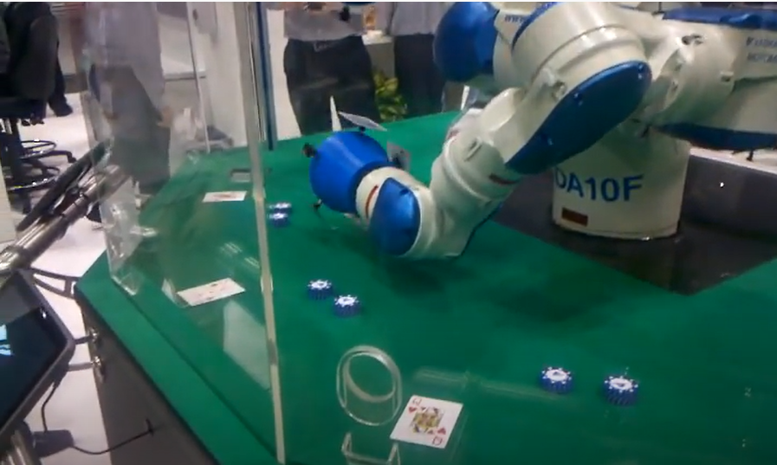

Figure 1: Yaskawa Motoman Robotics’ Robotic Blackjack Dealer [6]

Several projects implementing the robotic Blackjack dealer have been executed before. At Automate 2013, which is a convention to display advances in automation, Yaskawa Motoman Robotics debuted their robotic Blackjack dealer[6]. The humanoid dealer spins its arms, picking up cards one at a time using suction cups. The dealer uses a camera to read each card and uses computer vision to decipher each card, and each customer has a tablet that displays their current game situation. Our design improves off this design by greatly minimizing the costs. A device, like the one shown in figure 1, utilizes Motoman robotics, and the low end price for a second hand robot, which is worse than the one in figure 1, costs anywhere from $17,500 to $35,000 [7]. This price far exceeds the estimated cost of $200 for our prototype, and this solution fails because it does not solve the financial constraint for a casino.

# System Requirements

## Functional Requirements

### Physical Requirements

#### Dimensions

* The entire system should be able to fit on a tabletop and accommodate three players.
* The card moving mechanism should have a minimum clearance of 6” to allow room for the card drawing and flipping mechanisms.
* The playing surface should have a maximum clearance of 12” above the surface of the table. This will allow for both camera distancing and a compartment for component placement out of player view.
* The cards should be within 8” and 12” from the camera for the camera to read them.

#### Card Movement

* Cards shall be moved to predetermined locations from a starting location of the deck. These locations include a spot for the dealer’s cards, a discard pile, and evenly spaced spots for each player’s cards. Exact locations will be determined in development, however, with the defined location (the size of a standard playing card), there will be an allowed tolerance of +/- 0.5” from each edge of the designated area. This tolerance will also apply to overall drift over three games.

#### Speed and Timing

* The initial deal process should be completed in a reasonable period of time. To roughly approximate this, the total time should be less than or equal to one minute times the number of players, including the dealer, plus one minute. E.g. a 2 player deal shall complete in 4 minutes.

#### **Vacuum Generation**

* The vacuum system shall be capable of generating a lifting force to hold a single, standard playing card during gantry movement. A single card weighs approximately 96 grams.

### Electrical Requirements

#### **Motors/Motor Driver**

* NEMA 17 stepper motors operate between 12V to 36V and have a maximum current of 1.7A.
* Vacuum pump operates between 1.5V and 5V with a maximum current of .5A.
* DRV8825 motor driver requires 5V with a maximum current of 2.5A to motors.

#### Control Modules

* Arduino Uno operates between 2.5V to 5V with an average current draw of 50mA.
* Raspberry PI 4 Module B requires 5V with an average current draw of around 900mA.

### Software Requirements

#### Device Compatibility

* The main program with the game algorithm and image processing shall run on a Raspberry Pi.
* The secondary program, for motor controls shall be flashed onto and run from an Arduino Uno.

#### Program Language

* The main program with the game algorithm and image processing shall be written in Python.
* The secondary program, for motor controls, shall be written in C++. This will utilize a specialized version of grbl for this project’s gantry control and be stored in an Arduino Uno.
* Movements will be coded and stored in the Raspberry Pi as text and transferred at need to the Arduino Uno.

#### Betting

* The system shall allow players to “deposit” money for a starting balance through the touchscreen display input interface via a ‘deposit’ button at the start of a game.
* The system shall allow players to place bets through the touchscreen display input interface via the press of a ‘bet’ button.
* If a player’s bet wins, the system shall provide them with the winnings. On the contrary, if a player loses, the system shall collect the losing bet.

#### Image Processing

* The system shall have a method to process an image of a playing card and produce the accurate value and suit of the card.
* The system shall be able to communicate this value as an input for the game algorithm module.
* The runtime for the method shall be within 5 seconds.
* The accuracy for the method shall be greater than 99%.

#### Player Input

* The system shall have a method for the users to input into the system via tangible buttons or touchscreen buttons. These inputs will be for playing commands such as ‘hit’ or ‘stand’, as well as for wagering throughout the game.

#### Game Output

* The current state of the game shall be visible to the players at all times via a single display screen used for all players.
* When a user’s input is required, it shall be made very clear which player is responsible by showing a player number as well as the current hand.

#### Interfacing

* The Raspberry Pi shall be able to connect to and communicate with an external Arduino ATMega-style chip. This will be achieved via serial communication at a baud rate of 115200.

## Game Rules

The game shall have a standard Blackjack ruleset. This is defined below and is referenced from the ruleset used at *Hollywood Casino at The Meadows* [8]. No matter the number of players at the table, each player will only be playing against the dealer and not any other players.

### Card Values

* Numbered cards will have a value equal to their face value with the exception of the ace, which can have a value of either 1 or 11.
* If a player should bust due to a high ace, the ace's value is treated as the lower value (I.E. if the dealer draws 8 after a starting hand of an ace and a 3, the value of the dealer's hand is then calculated as 12 rather than 22).
* All face cards will have a value of 10.

### Starting

* Dealer begins the round by giving a single, face-up card to each player.
* Dealer then gives each player a face down card that only the respective player may know about.
* Players may split their hands into two individual hands if their starting hand has two identical card values. A player will receive two additional cards if they choose to split their hand: one for each hand they have for the round. Split hands require their own bet.

### Playing

* Sequentially, each player can request an additional card as many times as they choose (given they do not ‘bust’) by choosing to hit.
* When a player does not want any more cards, they can request to ‘stand’, in which case, the next player can ‘hit’ as many times as they choose.
* This process is continued until each player has had a chance to ‘hit’. After that, the dealer then begins drawing cards until they win (see player winning) or ‘bust’.

### Player Winning

* If the player’s hand equals 21, then they automatically win the round, regardless of the dealer's hand at the end of the round.
* If the player’s hand is more than the dealer’s hand before the dealer bust, then the player wins the round.

### Dealer Winning

* If the dealer’s hand equals 21, then they automatically win the round, given the player did not already reach Blackjack.
* If the player goes over 21 after a hit, then the dealer wins.

### Betting

* The minimum for each player is 1 unit.
* When the dealer’s face up card is an ace, each player has the opportunity to place an insurance bet, in which they bet on if the dealer's next card will bring their hand to 21.
* All winning bets will return the initial wager, plus an additional value equal to the wager returned. Contrarily, all losing bets will return 0 units.
* At any point, a player can ‘double down’, which doubles their current wager and deals one more card before forcing the player to stand if the extra card does put their hand above 21.
* At any point, a player can ‘surrender’ which concedes the game to the dealer and return half of the player’s wager to the player

# Design Constraints: Standards and Impacts

## Industry or Government Standards

Our final design will comply with FCC, OSHA, and UL standards regarding radio frequency communications, unguarded voltage protections, and transformer safety respectively. These standards are to be employed in our project to ensure a lack of interference between external systems and to prioritize the safety of any operators of our project.

The FCC standards concerned with our project are found in Part 15 of the FCC rules and regulations regarding operating frequency and interference. All the modules used in our project comply with the FCCs regulations regarding radio frequencies produced by digital switching logic and interference conformity and are being used within those acceptable ranges specified by the FCC standard [9].

The OSHA standards our team focused on meeting was Occupational Health and Safety standard 1910.303(g)(2)(i)(A) - (D), 1910.303(g)(2)(ii), and 1910.303(g)(2)(iii). These standards concern the level and accessibility of electrical equipment operating at or exceeding 50V. As the source of power for our design is by AC-DC conversion from a standard wall outlet, a sturdy and insulated enclosure for the system’s transformer is a necessity [10].

The final major standard our team focused on was concerned with the UL standards for transformers and power supply systems. These standards are a means of ‘recognizing’ transformers or other high-voltage, power electronics as safe and consistent in its construction. Though our transformer was sourced from secondary sources, it is still listed as being a UL recognized device. As this UL recognized transformer is being used in a proper manner (within primary rating, not being used in reverse, etc.) our project follows the UL standards for transformers [11].

## Impacts in Non-Technical Contexts

### Global, Cultural and Societal

Our project’s major impacts in a cultural/societal context are focused within the context of entertainment. This project could exist in places of entertainment or as a home product used at social gatherings or events and would be a novel means of playing a classic card game. As the basis of the game is a simple game of chance and is only related to gambling when a betting system is implemented, the concept could also be included in educational settings as a potential introduction to or an entertaining means of presenting probability and statistics to students.

### Legal Limitations

Gambling is defined and enforced differently for each state across the country. To ensure that we are not struck with charges for disobeying any gambling laws, this system will be designed without the feature of including real currency. To ensure we are not labeled as a ‘casino’ or other ‘gaming entity’, and to avoid requesting a license or permit from the PA Gaming Control Board for our activities, the wagering in our game will be with units that do not have any monetary value and will not require any cost to obtain. Additionally, the odds of winning will be truly random and there will be no ‘house edge’ or ‘house favor’ to give players the fairest chance for winning.

# Design Summary

## Hardware

### Primary Mechanism

The primary hardware mechanism for this design is based around a gantry model. Similar to the way 3D printers work, the gantry structure was constructed of 2020 t-track surrounding the play area with a beam in the middle supporting the card moving mechanism. This middle beam was moved via two servo motors positioned at the corners of the gantry and rode on two linear rod shafts using two ball bearings. Movement utilized a series of belts tied to the gantry. This belt system followed a CoreXY design to ensure that both servo motors that drive the system remain stationary as the cross-beam and gantry plate are moved[12].

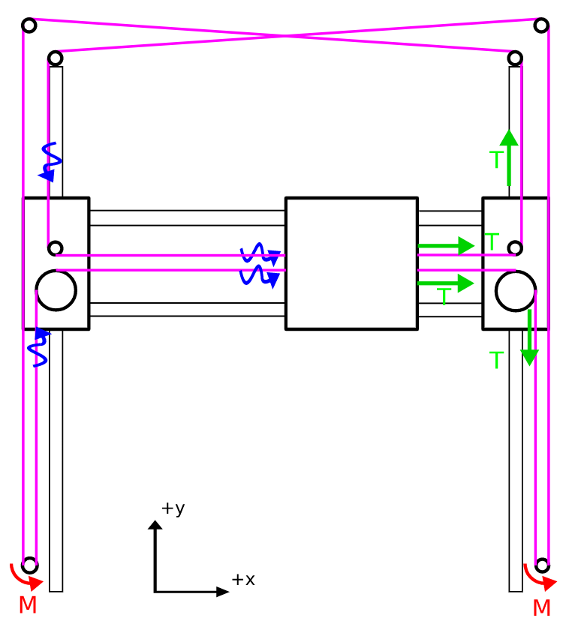

Figure 2: Gantry Design (top view)

Upon the middle cross beam, a third servo motor is responsible for moving a mechanism vertically on the beam. As can be seen below, the mechanism has a vacuum pump with the suction piece positioned at the bottom. As the servo motor runs, the suction cup moves up and down above the surface of the table. When the suction cup is lowered, the vacuum pump is turned on using relay controls, and when it is positioned onto a playing card the suction will pick up a single card and keep a hold of it to allow for movement around the table.

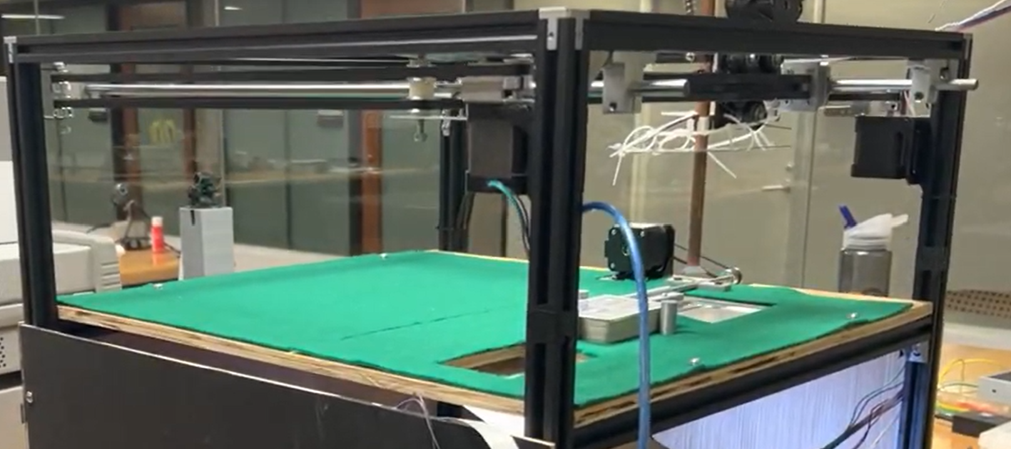

Figure 3: Gantry (side view)

In figure 3, you will notice the two previously mentioned motors that control motion in the XY-plane. Additionally, you can see the copper tube that is riding along the gantry as well as the suction cup attached to its base.

### Vacuum Pump

For our design, our vacuum pump needed to be able to generate enough negative pressure at its output to lift a standard playing card. Given that a standard playing card weighs about 96 grams, the amount of force required to lift a single card can be calculated by:

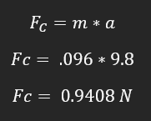

Figure 4: Force Calculations for Card Lifting

This means that our pump needed to be able to create a negative pressure to generate a force greater than .9408 N to lift the playing card into the air (neglecting air resistance inherent to lifting the card at a given speed). The pump we used was a 370 Mini Vacuum Pump (FIT0801), figure 5. Supplemented with a suction cup, the vacuum pump did well in providing the suction needed to lift a playing card.

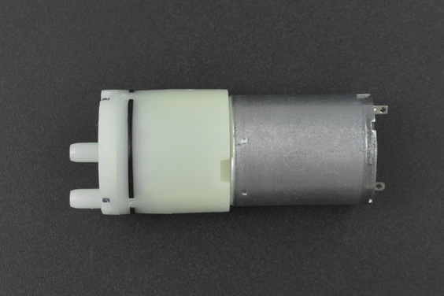

Figure 5: Vacuum Pump Utilized in Design

. We soldered the pump’s connections to ground and the normally open contacts of a relay–with 5V supply power–to provide switching control over the vacuum pump. This was mounted above the Z-motion servo motor on the custom designed 3D printed gantry mount shown below:

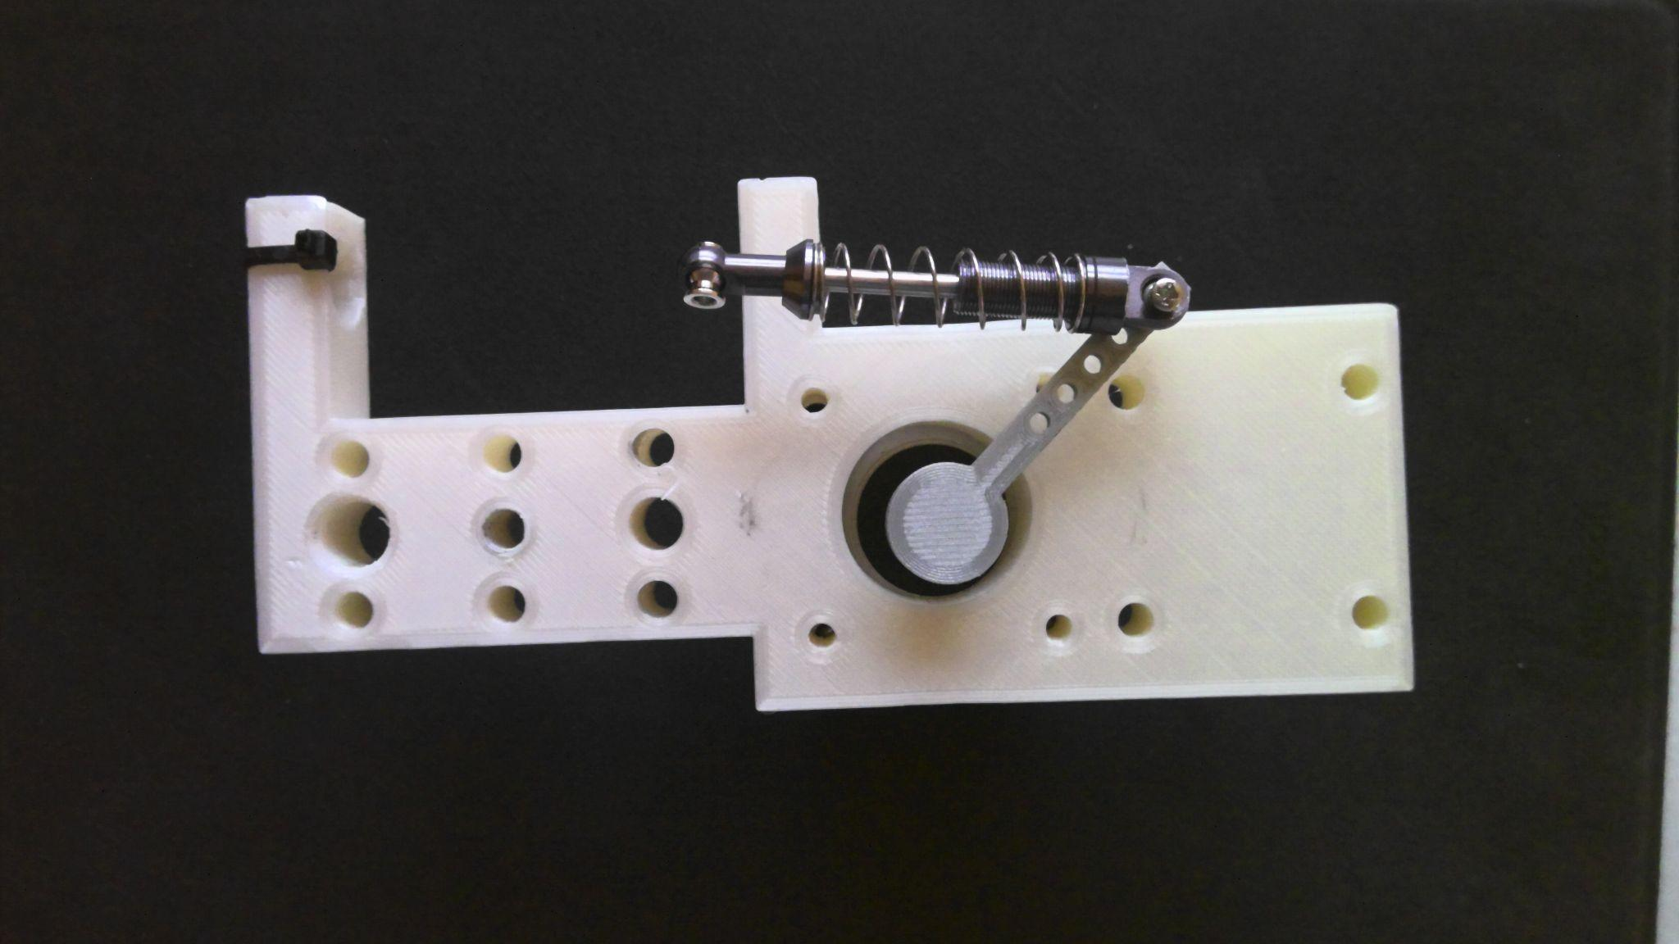

Figure 6: Gantry mount for Z-motion and vacuum mechanism

### Power Supply

We used a standard wall outlet with a step-down, AC-DC conversion circuit to get the required voltage levels for our system. Our transformer was a Hammond 165P30 center tap, step down, 115V:30 V 5A unit that had its output fed into a standard RC filter. Below is an image of the transformer, its schematic, and images depicting the no-load voltage across its output terminals:

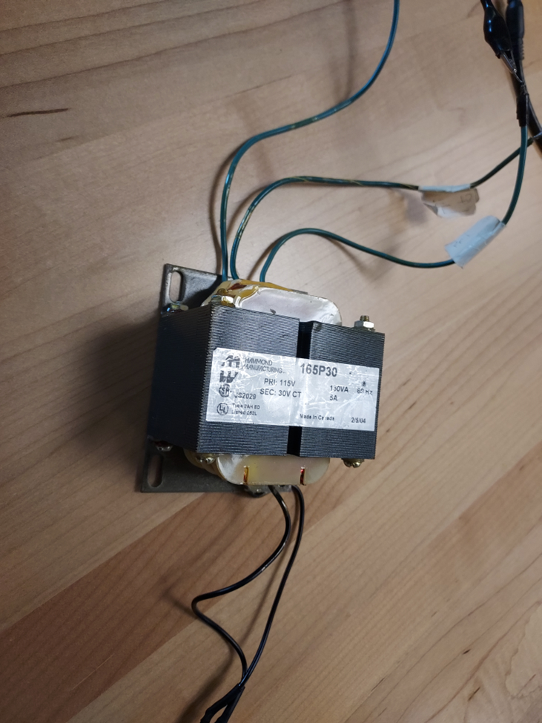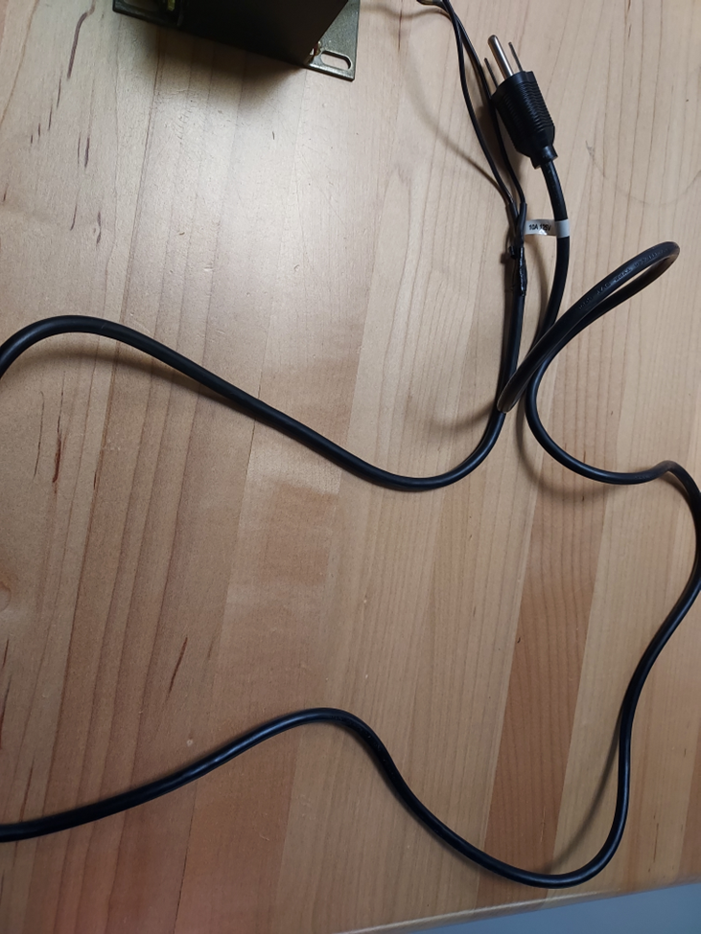

Figure 7:(left) Transformer to be Used for the Design

Figure 8: (right): Wall Plug Connection Attached to the Primary Side of the Transformer’s Lines

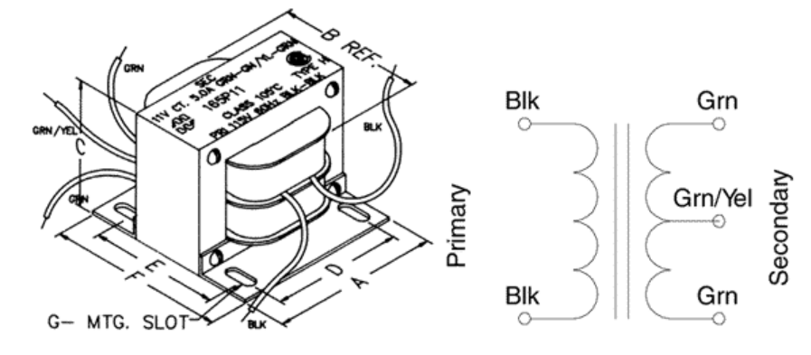

Figure 9: Schematic of the Transformer’s Design. The green/yellow wire indicates the center tap of the transformer, off which we could use to power the smaller components so as not to waste power burnt off in regulation. [11]

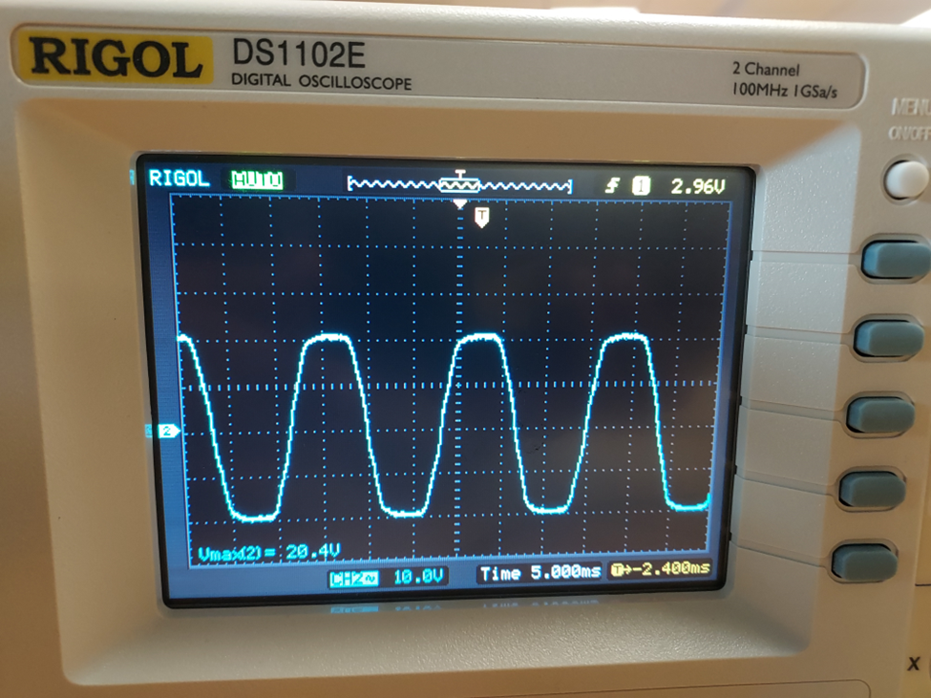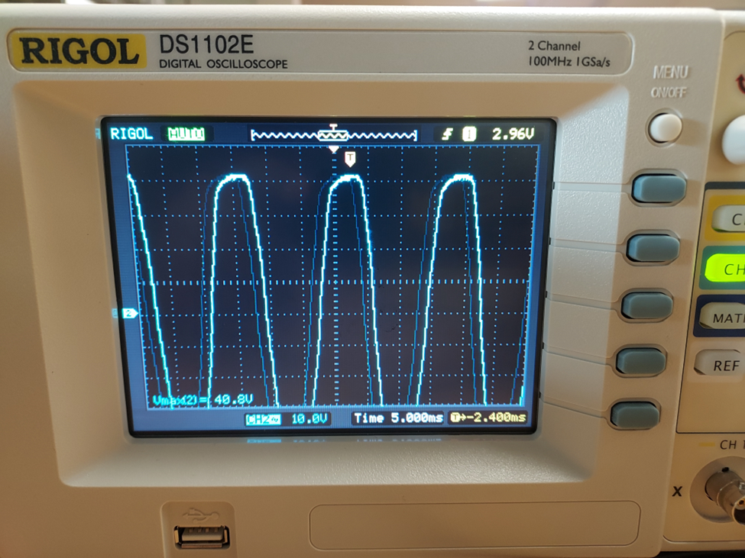

Figures 10 and 11: Waveforms of the Open Load Conditions of the Transformer. The left image uses the center tap of the transformer while the right uses both ends of the transformer. Both experience minor saturation.

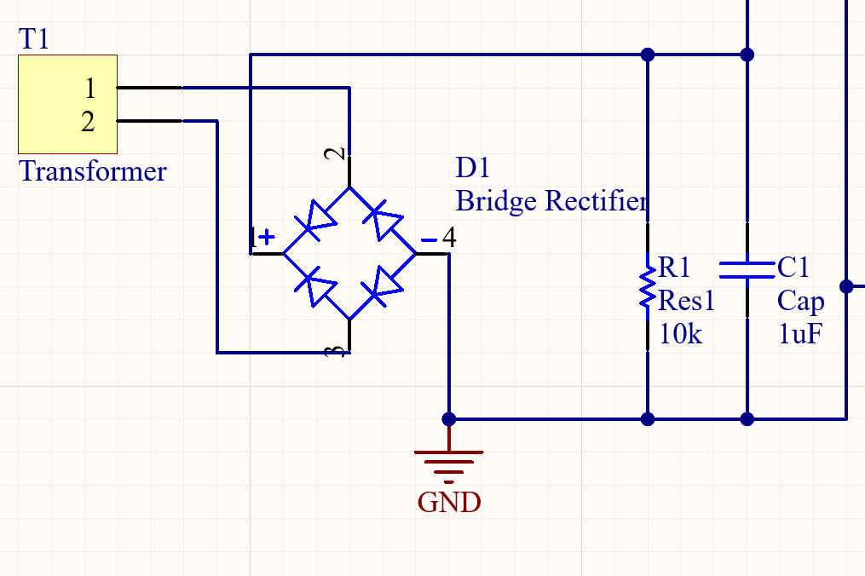

Figure 12: Altium Schematic of AC-DC conversion circuit

One key aspect for concern in filtering the output was to ensure that the ripple factor inherent to all AC-DC conversion circuits is minimized. For the purposes of this project, the limit for ripple in our system was constrained to be a 2% AC component in the DC signal. With consideration to the low level of the ripple expected in the system, the approximate calculation for the ripple in for a RC rectification circuit is given below[13]:

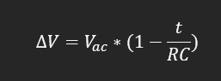

Figure 13: Ripple Calculations

So, to determine the optimal values to meet this threshold, the ripple was set to V (2% of 20) while t was set to 1/60 (.0167) to determine the highest value of RC that could be used while maintaining a ripple below .02. Below are the calculations for the highest value of RC that could be used:

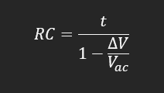

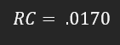

Figure 14: Lowest RC Value Required to have a Ripple Output of less than 2%

The rectified voltage was then fed to 3 regulation circuits: one for 5V, one for 20V, and once for 12V. Our 5V regulator will power the control modules (Raspberry Pi and Arduino Uno), Vacuum tube, motor drivers, and other peripherals while the 30V supply will be the input to our stepper motors. Lastly, the 12V supplied a cooling system used to supplement the heat sinks attached to the motor drivers. Below is a flowchart to show the electrical connections that was made in the completed circuit:

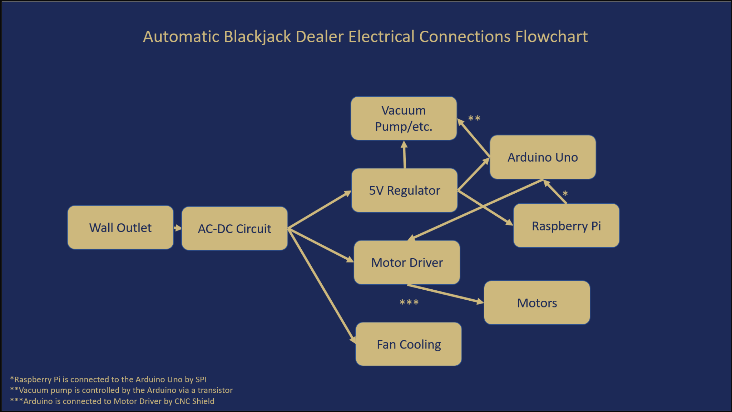

Figure 15: Flowchart for Project’s Electrical Connections

Because our power supply conducted high voltage on the primary side, a containment unit was necessary to ensure the safety of anyone interacting with our project. To that end, an acrylic containment unit was constructed to contain our transformer while our wires were properly insulated to minimize any potential for electric shock.

### Motors and Drivers

The design employed 3 2-pole NEMA 17 motors and a vacuum pump. The NEMA motors operate between 10V and 36V with a maximum current draw of 1.7A on either pole, while the vacuum pump operates between 1.5V and 5V with a maximum current draw of 0.5A.

To control the NEMA motors, we used DRV8825 motor drivers. Each driver controls one motor through PWM on an H-bridge inverter’s transistors and limits current into each motor using an onboard foldback current limiting circuit to prevent damage to the motors in the case of a current draw over 1.7A. The DRV8825 motor drivers connect to a CNC shield to properly route connections from the Arduino Uno to the drivers.

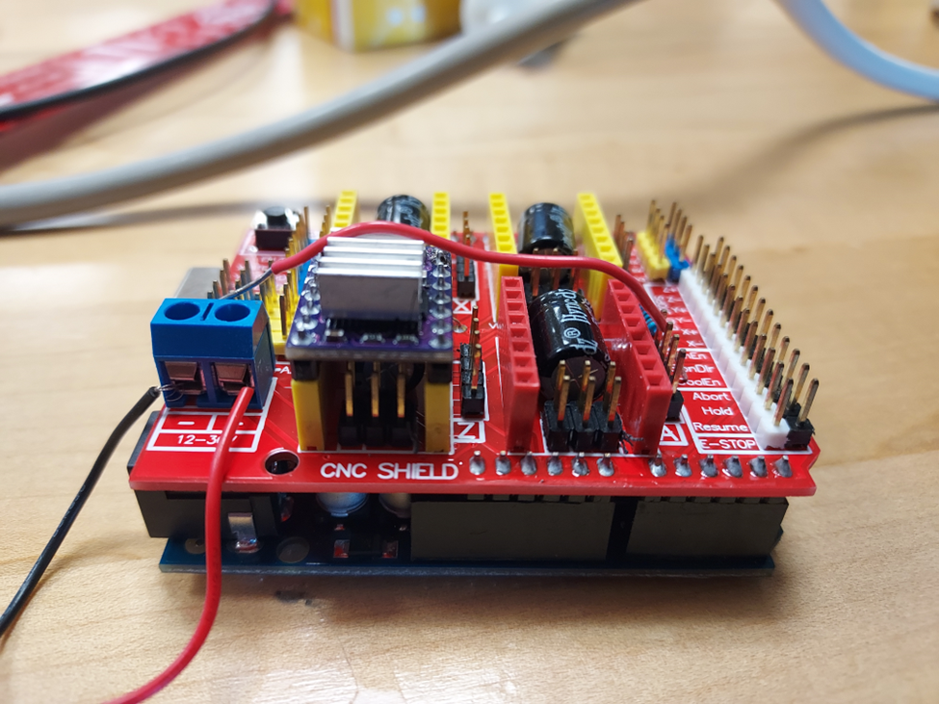

Figure 16: CNC Shield with one DRV8825 Motor Controller. A motor management/protection unit that connects to the top of the Arduino Uno. Can control up to 4 motors at a time.

The vacuum pump was controlled via a relay bridging the pump windings and the DC-DC converter output. The relay is controlled by a digital output on the Arduino Uno. This setup allows for an adequate current draw for the motor compared to the Uno’s analog output.

### Flipping Mechanism

Within the surface of the table, there is a cutout from the table that holds a piece of transparent acrylic. This piece was attached to a servo motor to allow for flipping, this can be seen in figure 3. It was never completed due to time constraints and hardware issues, but was very near implementation. The figure below shows the hinge piece that is connected to the acrylic, as well as the gear that interfaced with the servo motor via a belt.

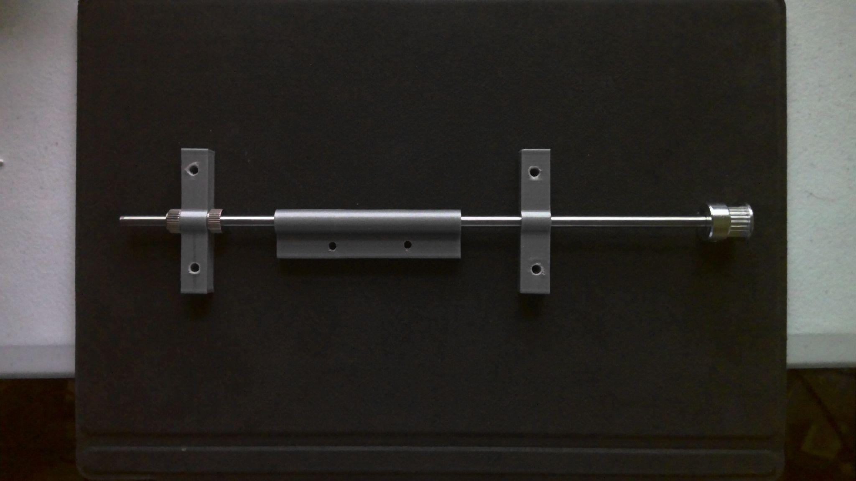

Figure 17: Flipping Mechanism.

### Control Modules

The entire system was designed to run on a combination of a Raspberry Pi 4 and an Arduino Uno. The Pi harbored the logic for running the game and controlling the inputs and outputs, while the Arduino received commands from the Pi and translated those into controls for moving motors within the system.

Our control modules both require 5V to power. This 5V supply came from a small regulation circuit employing a 5V DC-DC converter to step the voltage down to step the voltage down from 20V to a more manageable 5V. The Arduino Uno typically required around 55mA of current, while the Raspberry PI typically drew around 800mA.

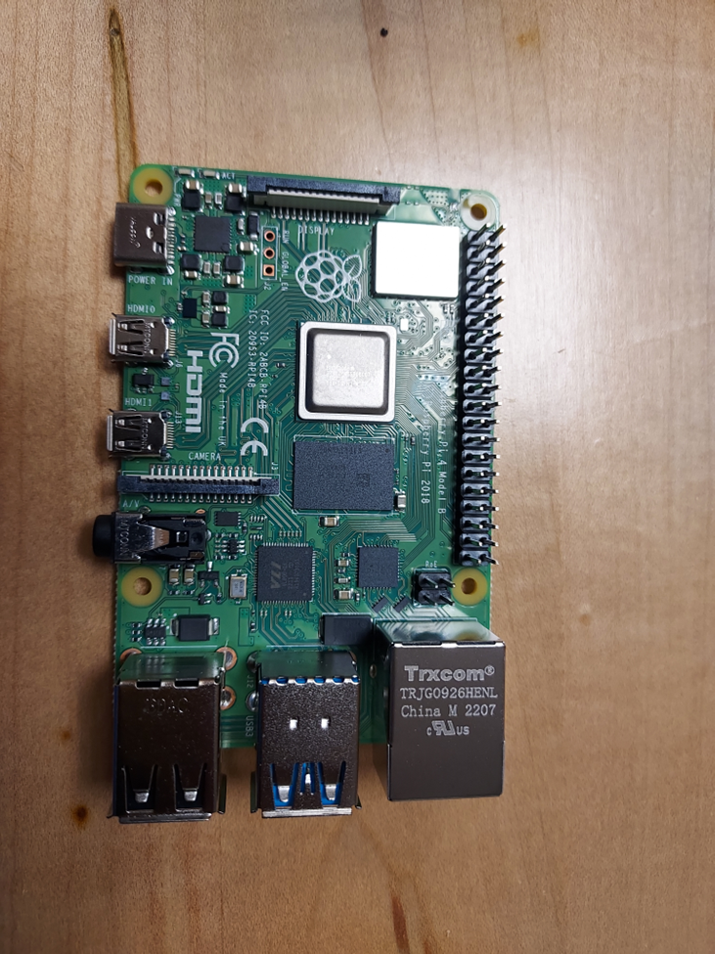

Figure 18: Raspberry PI 4 Model B Board. The focal point for the management of our modules.

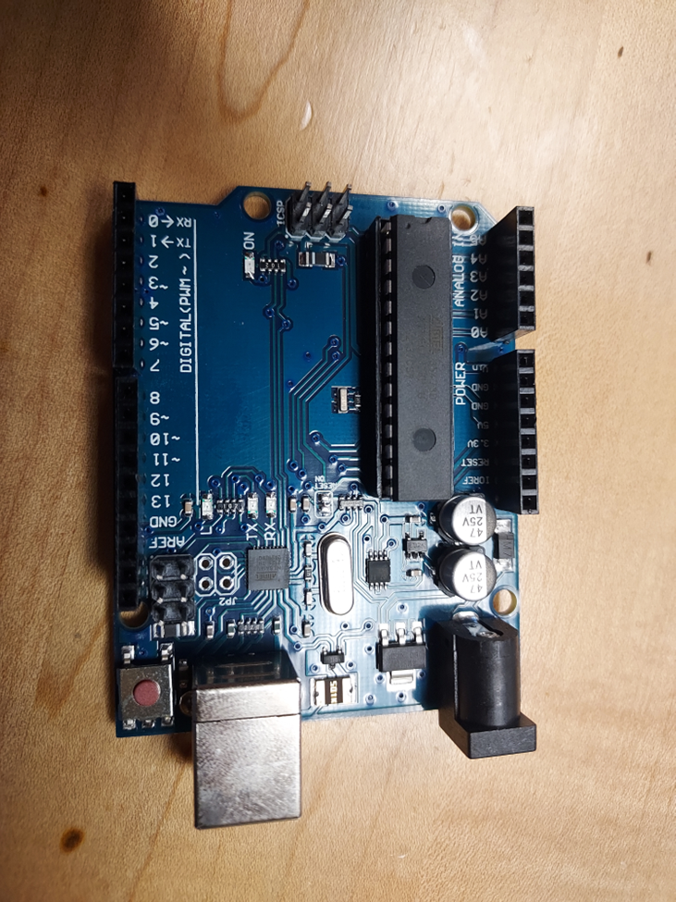

Figure 19: Arduino Uno Unit. This board will control the motors through a CNC shield that attaches to the top of the unit.

These systems came together in the finalized PCB shown below:

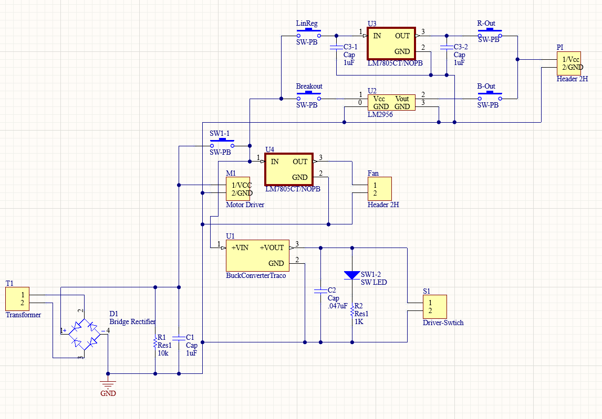

Figure 20: Fully integrated schematic for the power supply.

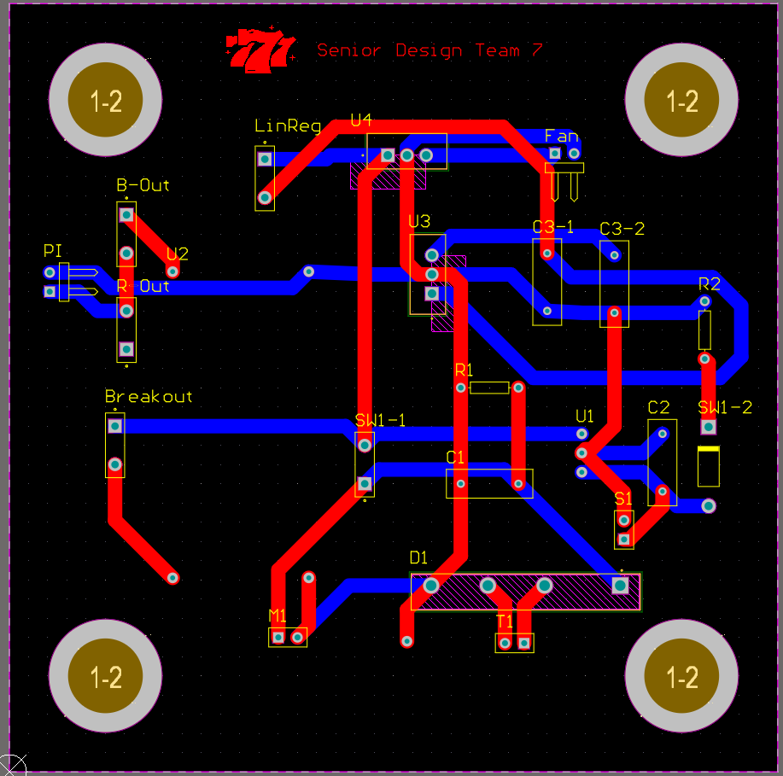

Figure 21: Fully integrated PCB. Annular rings were added on the corners of the board so that it could be attached to the mechanical system.

### Computer Vision

Beneath the flipping mechanism is where a camera is positioned, facing upwards through the acrylic in the table. The camera is the Arducam for Raspberry Pi Camera Module with Case, OV5647 Sensor Adjustable and Interchangeable Lens M12 Board. As cards are placed onto this, the camera is able to take a picture which is then processed. This camera is directly connected to the Raspberry Pi through a ribbon cable.

### Hardware Input/Output

The Raspberry Pi interfaces with the Arduino Uno, using serial communication, by streaming commands to the gantry based on the game logic. The Arduino parses those commands interfaces with the three separate servos via a CNC shield to control gantry motion in the XY-plane and the vertical position of the vacuum mechanism.

The player can interface with the game through a touchscreen. This screen is connected to the Raspberry Pi and provides output information to the user and when the user is prompted, it reads in user input from the screen.

## Software

### Image Processing

The image processing module will be designed for the purpose of taking an image of the active playing card and determining its suit and its value. The value is the most important part of this module, as that determines the point value for each card. The suit is not imperative for the functionality of the game, however, an improper suit identification will be reflected on the GUI. It is desired to have both suit and value accurately identified for the best user experience possible.

The module uses OpenCV, a library in Python, to capture the images and apply the proper methods to predict the card. There was one class developed, called CardDetector, that contained all of the methods used to analyze the card. There was an additional function, called getCard(), that would take the picture and call the methods in CardDetector to predict the card’s identity. A flowchart of how the algorithm was designed can be seen in figure 22.

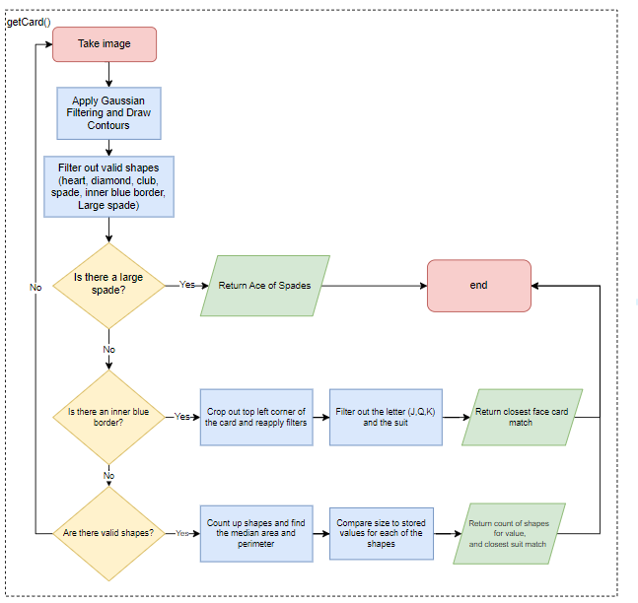

Figure 22: Image Processing Flowchart

Upon request for a card, the camera turns on and takes an image. It then calls a method that applied Gaussian blurring, graying, and adaptive thresholding to receive an image that is stripped of any glares or dirt.

Next, contours are drawn for each card. This draws shapes on the image where an absence of white is detected, so any part of the image that isn’t the basic white background. Each of these contours has an area and perimeter, which are retrieved using the OpenCV library.

The full list of contours is sent through several filters. First, each contour is checked to see if its area and perimeter fall within the determined range for a diamond, spade, club, or heart. If the contour’s sizes match one of these four shapes range, it is added to the shape list. This list, once complete, finds the median area and median perimeter, and re-filters the list of shapes to make sure they are within a specified pixel range. This is performed in the off chance that an auxiliary shape is picked up by the initial filtering so that it is filtered out before computation, because an auxiliary shape will likely be an outlier in respect to the median sizes.

The second filter searches for a singular, large rectangular box in the middle of the card. If this box is found, that means the card is a face card.

The third filtered searches for a singular, large spade. The ace of spades is the only card that differs from the rest of the cards, as there is a much larger spade than the spade that shows up on the 2-10 cards. The other three aces have a symbol that matches the same size as the 2-10 cards. If this extra large spade is detected, it is recorded as existing.

These filtered lists are returned to the getCard method. If there is a large spade detected, then the card is identified as the ace of spades and returned to the game logic algorithm.

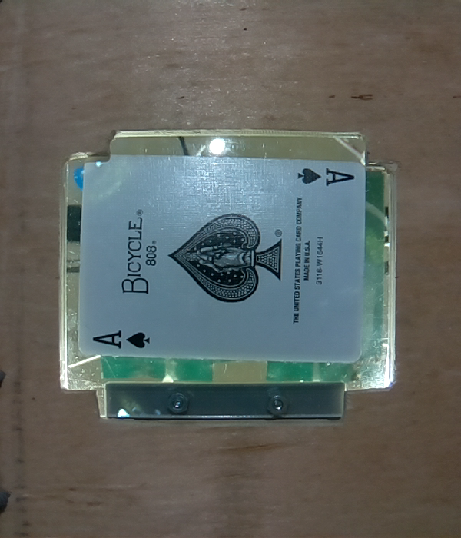

Figure 23: Ace of Spades; Pic and Contour

If there is a large blue box detected, the findFaceCard method in the CardDetector class is called. This method crops out the top left corner of the card, and applies the same type of filtering that was done initially. This time, it filters based off of the sizes for a J, Q, and K, as those are the 3 symbols representing face cards. It also filters based off of the sizes of each of the 4 suits again.

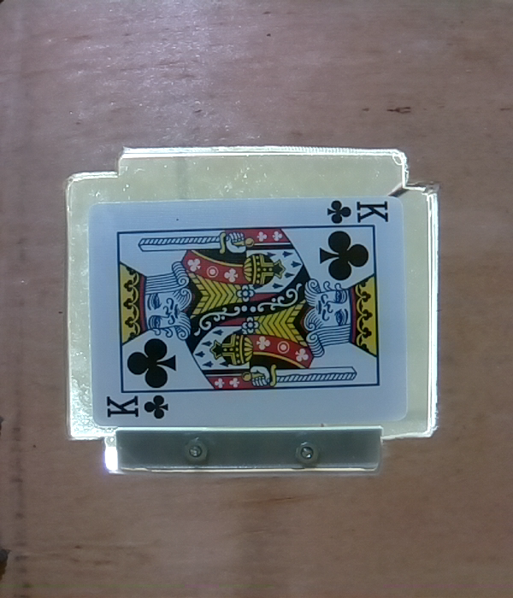

Figure 24: King of Clubs; Cropped Pic & Contours

Once these are filtered out, the size of each of the shapes is compared against the preloaded values for each of the shapes, and the algorithm predicts the identity based on which shape has the most similar size.

Once identified, the Card object is created with its identity and returned to the game logic algorithm. It is important to note, that all face cards have a value of 10. The algorithm should accurately identify which face card is present, but the game will work perfectly even if the algorithm believes a king is a jack, as they are both worth 10 points and have no other effect on the game.

Finally, if the card does not have either a large spade or a blue box, and it has shapes found, it is a numerical card. The findNumberCard() method is called from CardDetector. This method finds the median perimeter of the shapes, and uses this value to predict which of the four suits the card is. It then counts up the contours that have survived the filtering, which is the value of the card.

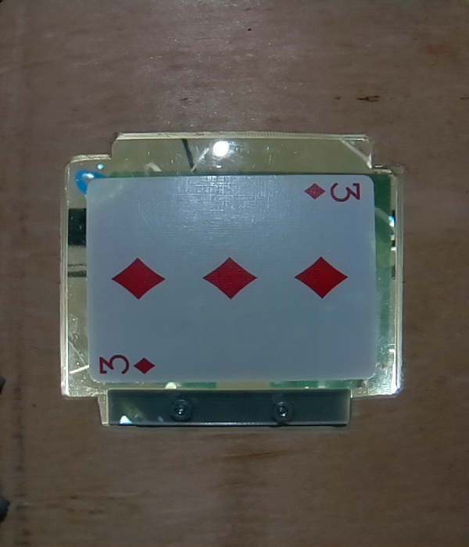

Figure 25: 3 of D; Pic & Contours

If the algorithm didn’t find any of the eligible qualifiers, it will return a Joker, which triggers the getCard method to restart and take a new photo. This helps in case the card does not make it to the camera in time for a picture.

### Backend Game Logic

The algorithm behind the game was built using object-oriented methodology. This means that the game was based around a Table that contained a Dealer and Players, each of which have one or more Hands, which has a number of Cards. Within each object, there are attributes, such as scores, sizes, and various status flags, and methods that allow for the interaction and altering of these attributes. The game also has a set of functions for the game as a whole, such as performing actions and calculating winners.

A particular challenge that came up was that every object has an attribute for a set of coordinates and this means the system is completely reliant on the cards not being touched. Given a system without a flipping mechanism, the game logic relied on the designers to make sure that when cards were manually flipped, they were not move too far from the position they were placed at.

The game was designed with a standard Blackjack ruleset. This includes hitting, standing, splitting, doubling, and surrendering. Aces are initially handled with point values of 11 until they need to be reduced to a value of 1. When calculating winners, the losing scenarios for the Player are first checked and compared against the Dealer. With each result, the payouts are distributed and upon restarting the game, everything is reset to initial default or empty values.

The way the game runs is through a single main python file. Due to the nature of the GUI library used, Kivy, the program will run in an idle loop until event handlers call functions or methods from the blackjack algorithm. Upon returning to the idle loop, any changes that were made to the visual UI will be updated all at once. This posed problems that did not allow us to do too much algorithm work before returning to the loop, which will be later discussed.

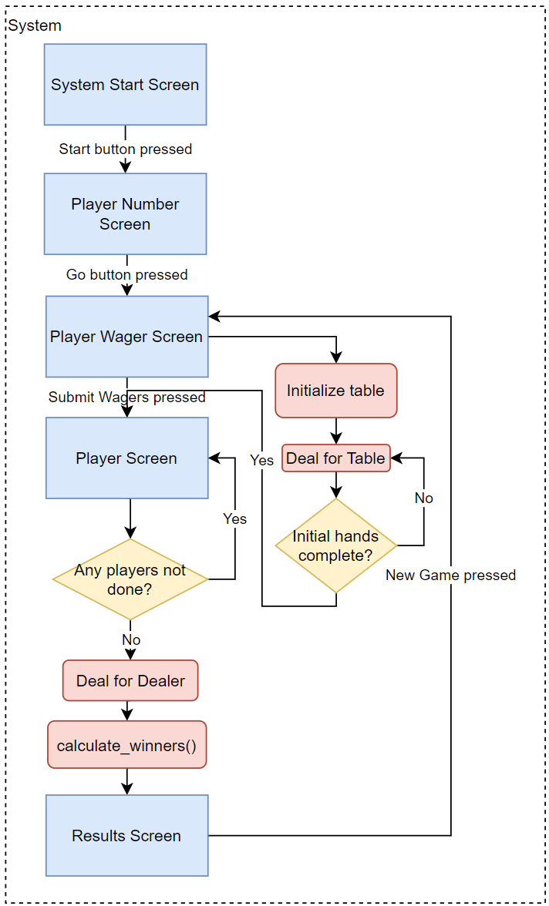

Figure 26: Game Logic Flowchart for a Game of Blackjack

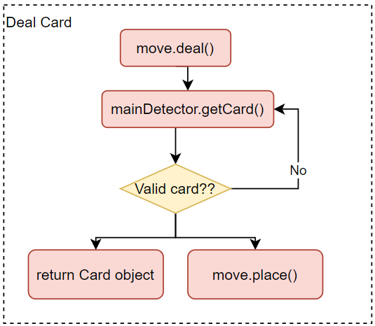

Figure 27: Flowchart for dealing a card with integration

### User Interface

Upon launching the game, there is a beginning start splash screen. Following this is a number of players selection screen; the number selected here persists until the program for the game is restarted, as player funds should persist. The next screen is where the players input their wager before starting the game. After this, the initial deal begins, and once complete, the first player is displayed. The available players can be cycled through using ‘next’ and ‘previous’ buttons; each player's action buttons will be disabled when they have no action to perform, and the completion of the dealer’s deal only begins when all players have entered this state. The final screen shows the dealer’s hand, the winning or losing state of each player’s hand(s), the remaining credits for the player, and a new game button that prompts the resetting of the game and transition to the next iteration.

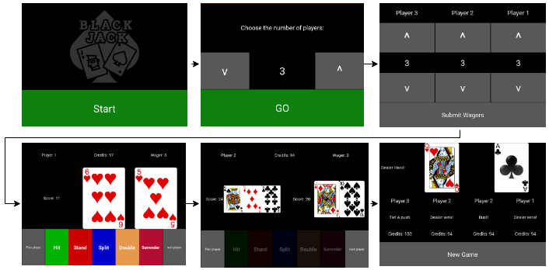

Figure 28: Example UI screens through a game

A challenge of using the GUI library of Kivy was working around the previously mentioned idle loop and how the updates to what the user sees are handled. To work around this, the algorithm was heavily broken up in the backend and more transitional buttons were added so that shorter sequences of logic could be performed and update the screen for the user in a timely manner. To prevent users from doing unexpected actions, every button would be temporarily disabled immediately upon pressing it, and then re-enabled, if necessary.

### Motor Control

For our gantry system, GRBL–an open source, readily available method of programming that is widely used in DIY CNC machines–was implemented as our method of control. Gantry control is implemented using “g-codes” to move to software defined locations [15]. These locations were mapped out by our team, then stored and manipulated by the game logic. The accessible area of the play area is 250mm by 375mm, so the Arduino tracks its position to prevent overtravel. A controller like that in figure 23, was used for testing and verification.

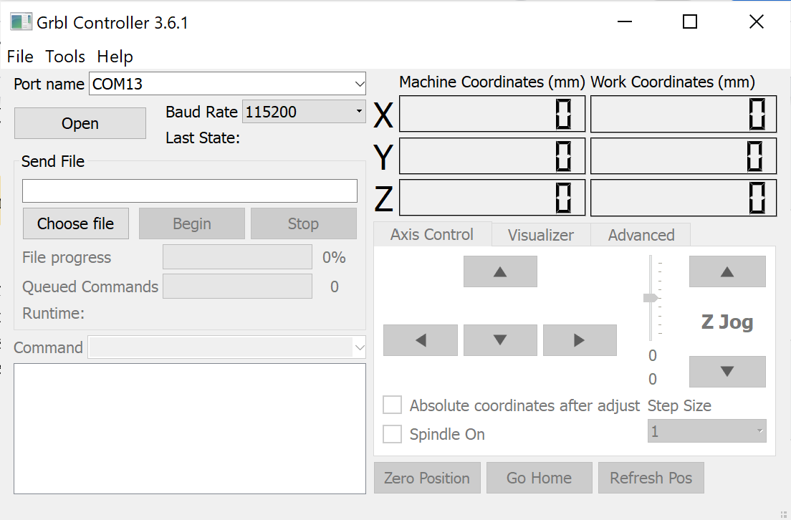

Figure 29 : Grbl Controller v3.6.1

GRBL works in the cartesian coordinate system and commands are stored as modifiable strings in a python object. When supplied with coordinates from the game logic, the object functions modify the g-code strings to perform the appropriate gantry movement and stream them from the Pi to the Arduino. The streaming object is called Move() and has four functions: draw(), place(), discard() and setG().

The draw function is invoked whenever the game logic needs to draw a card from the deck. It takes the number of cards that have already been dealt as an argument to calculate the offset in the Z-direction necessary to pick up a card. It then sequentially streams commands to move the gantry to the deck, pick up one card, move it to the acrylic for imaging and drop it.

The place function is used to move a card from one location on the surface to any other location. As arguments, it takes two sets of [X,Y] coordinates, though the first coordinate defaults to the acrylic to simplify dealing and hitting. The function uses formatted string literals to insert the coordinates, then streams those literals to the Arduino. This will move the gantry to coordinate 1, pick up the card at coordinate 1, move the card to coordinate 2 and drop it. Finally, it will move the gantry back to the deck.

Discard takes a stack of [X,Y] coordinates as an argument. This function is only used at the end of a game of blackjack. The function iterates through the entire stack of coordinates in reverse order of how they were placed on the table, i.e. the last card played is the first to be discarded. It moves the gantry to the coordinates, picks up the card, moves it to the discard slot and drops it.

Finally, setG is only used when the Move object is initialized. It has a list of settings that should be already correctly set in the Arduino, but sending them at initialization is an easy way of verifying the proper step, acceleration and speed performance of the motors.

# Team

The team assigned to this project is composed of four individuals, two of which are electrical engineers and the other two of which are computer engineers. The electrical engineers will be focused on the physical, tangible components of the system with Kyle designing the system’s structure and movement while Nicholas designs the system’s power specifications and component connectivities. The computer engineers will design the less tangible parts of the system with Curtis designing the non-trivial algorithm as the game’s logic while Luca focuses on designing the image processing module of the system.

## Kyle Cullen

Kyle will be responsible for the gantry system design. The gantry system is required to be capable of moving anywhere within the playing area in the xy-plane to allow for card positioning and placement. It must also support a method of physically picking up playing cards and subsequently depositing them in a particular location–this will be accomplished utilizing a pneumatic suction via vacuum pump and may require a method of z-motion. It will also require choosing and implementing an appropriate gantry control scheme to allow for accurate xy-positioning. He is also responsible for interfacing game logic with gantry control in conjunction with Curtis.

### Skills learned in ECE coursework

ECE 1138 (Cyber Physical Systems) and ECE 1895 (Junior Design) combined and applied skills learned in many previous courses–ECE 0301, ECE 0302, ECE 1212, ECE 1673, etc. Kyle learned the underlying structure of microcontrollers and how to apply this knowledge to control. This required interfacing and processing various sensor inputs and adjusting outputs based on both finite state machine and PID controls schemes. It also gave him experience implementing algorithms to translate data into useful system and user feedback. Junior Design supplied him with significant experience on Arduino programming and interfacing with inputs and outputs, which will translate directly to gantry control using the Arduino and interfacing with the game logic.

### Skills learned outside ECE coursework

Kyle worked as an electrician for 5-6 years in both the Navy and industry. This provided significant troubleshooting experience and familiarity with mechanical and electrical system interfaces. He has also worked as a project engineer for the past two summers, which has provided him with extensive project management skills in design, teamwork and budgeting. Additionally, his last project this past year was upgrading the line control scheme at a manufacturing plant, including interfacing with new sensor configurations and tuning new drive systems. This experience will help with his current project goals.

In order to successfully execute this design:

* He will need to familiarize himself with different XY-gantry control schemes and choose the method that will use based on pros and cons and project constraints.
* After the control scheme is decided upon, he will have to decide on the implementation method–whether to use an existing software method such as GRBL, or to program a method specifically for this project.
* This will require him to learn different servo control methods for the hardware to be used and understand the limitations of each.

## Nicholas Lowe

Nicholas will be responsible for the creation of the power supply and the development of the PCB connecting the various modules developed by the other members of the group. His other roles include supporting Kyle’s motor controls and operations as well as creating various parts and enclosures for certain modules including an enclosure for the power supply as well as custom made parts for the gantry. He will also be responsible for aesthetic aspects of the design including lights and exterior designs of the dealer given that the minimum standard for project completion has been achieved.

The skills that make him suited to these roles include his 2 rotations spent working with power management and monitoring systems at Eaton Corporation, a single semester research project under the University of Pittsburgh’s Material Science department in which he developed both an LED driving circuit and performed preliminary tests on a current transformer harvesting circuit for an optical interrogator, and his personal knowledge of CAD design from Junior Design Fundamentals as well as prior experiences with AutoCAD.

### Skills learned in ECE coursework

The skills that he will implement from prior ECE courses include knowledge of AC-DC rectifier design, DC regulation, and PCB design. The AC-DC rectifier design takes aspects of ECE 102’s use of non-linear characteristics of components such as diodes and transistors alongside ECE 1701’s focus on high voltage/current design elements such as transformers and the considerations that coincide with them. These characteristics of these components come together to create the basis for the AC step down, rectifier, and regulation circuits that comprise a typical power supply.

His skills in PCB design came from his time in Junior Design Fundamentals. The course gave me knowledge of PCB design considerations such as how trace width affects the reliability of the PCB, what steps should be taken to reduce unintentional capacitances in the circuit design, and how to mitigate unintentional antennas in board traces.

In addition to the aforementioned courses, aspects of other courses like Power Electronics Conversion Theory, Analog and Digital Filter Design, Electromagnetics and Electric Machinery may be pertinent to his secondary roles in the project given enough time to move on to more aesthetic aspects of the design.

### Skills learned outside ECE coursework

Much of the major research that he will be doing during this project will be focused on motor and motor control systems. While he has a pretty good handle on most of the aforementioned aspects of my roles, motor operation and powering has never been a thing he has ever dealt with at length. As a result, the general operation of stepper motors as well as their power requirements are foreign to him. He has already had ample opportunities to look through various videos and text concerning stepper motor fundamentals and the means by which they operate. In looking into them already, He has already determined the properties that allow them to work and am already familiar with some of the components used for their operation (H-Bridge inverters, current limiters, etc.).

Another aspect of the project he will need to do research on is the optimal usage of the vacuum pump included in our chosen design. More specifically, he would need to get a better grasp of the mechanics behind the pumps suction ability, and determine the best means of powering in such that the pump will be able to suck the cards up as intended

* Suction with vacuum pump
* stepper motor operation and control

## Curtis Maher

Curtis will be primarily responsible for developing the non-trivial algorithm that is the game logic. This will essentially be core to the system as it must handle inputs from several other modules and then through its functionality, it must disperse outputs to several different modules. Alternate roles within the team will be to assist in the implementation of the computer vision module with Luca and to assist in the development of the motor control software with Kyle.

### Skills learned in ECE coursework

Several classes from the ECE department have contributed to Curtis’s knowledge that will benefit him in designing and developing his portion of the project. The first class is ECE 1140 as that class gave him a clear understanding of how to explicitly design and develop a software system from the beginning, including all the requirements and documentation, through to the end, including a functioning and thoroughly tested prototype. Another takeaway from that class is iterative development, which having and understanding of will give him a good pace to complete project milestones before predefined deadlines.

The next class that will benefit Curtis throughout this project is ECE 0302, as that class dealt with understanding and developing algorithms. This will prove useful as he will be designing the algorithm to implement the game logic of Blackjack. While the rules of Blackjack will not be newly developed, he will have to implement the functionality of the game through a thought-out program.

Another class that will prove beneficial is ECE 1175. The topics learned from this class will help him in working with a Raspberry Pi, interfacing with embedded system devices, and handling I/O devices and the interrupts that typically come along with these devices. As Curtis is currently taking this course, he will have to do my own research using outside resources alongside looking ahead at future lessons and future readings from the provided text to make the topics more applicable sooner rather than later.

### Skills learned outside ECE coursework

Outside of coursework, Curtis has worked with the Python programming language in a side project of developing a software bot. This project included concepts such as object-oriented programming as well as interrupt handling that will relate to necessary requirements of developing software in this project. Additionally, this project was iteratively developed and included many testing steps which will prove to be very beneficial when developing the software portion of the system and ensuring that all components of it perform as accurately as expected.

Another skill that Curtis has picked up overtime is a good understanding of the game of Blackjack. This may seem silly, but this knowledge will help to be very advantageous as he will not have to learn the rules and behind-the-scenes logic of a new game. This comfortability will make development substantially easier, allowing for more time to optimize the program and test it thoroughly.

## Luca Mahoney

Luca will be responsible for the image processing module of this project. Luca will develop a module that is responsible for receiving an image of a playing card and producing the proper value. The suit may also be identified, yet is irrelevant for the outcome of the game. This module will be connected to the game algorithm module, because the algorithm is dependent on which cards are dealt. Luca will also be required to setup and troubleshoot the camera, which will be connected to the raspberry pi.

### Skills learned in ECE coursework

There are several courses that prepared Luca with the skills needed for this project. ECE1175 provided him with his knowledge on the raspberry pi, as all of the projects in that course utilized the pi. This will allow him to run programs and modules with ease. He also learned about interfacing with microcontrollers in this course, which he will need to use to forward the output of my module to the module that Curtis is designing.

Another course that Luca learned valuable skills in was ECE1140. This course gave him the majority of his python knowledge, as his group wrote their train simulation fully in python. This prior experience in interfacing and communicating with other modules in python will be valuable, as Curtis and Luca will need to have their two modules communicating, and they will both be written in python. This course also taught him the requirements of software engineering and the standards that he will need to follow to develop proper code. He also learned valuable teamwork and communication skills vital for a project of this scope.

He also will pull information from ECE1145, which further reiterated those skills and coding practices that were introduced in ECE1140. This course also provided him with experience in game design, which he can use in the creative aspect of the project’s overall customer experience. Both ECE1140 and 1145 focus on the customer, and designing interfaces and modules that are comprehensible and enjoyable.

He will use his knowledge gained from ECE0202 in using microcontrollers to interface with the camera for his module. This course focused on receiving inputs and processing them, which he will need to do for the image processing. Luca will also use his knowledge on data structures learned from ECE302 and ECE1170 to create a code base that efficiently stores data.

He will use the knowledge gained from ECE1180, where he made several large scale simulations and games in python, to properly structure methods and classes that he will need to make for my module.

Finally, Luca will use the skills gained in ECE1895, where he gained hands-on experience in prototyping. This course taught him the importance of getting a functioning prototype, and he learned how to interface an arduino, which will be used by the team as they communicate from the pi to the arduino for gantry controls.

### Skills learned outside ECE coursework

For this project, Luca will need skills in computer vision and image processing. He did not take ECE1390, so he will use the skills learned from completing several online courses on computer vision. These resources were provided to him by Dr. Ahmed Dallal, the professor for ECE1390, so they should be sufficient for this project. If not, he will need to obtain further knowledge on this topic, likely through Dr. Dallal, Dr. Mai Abdelhakim, or the team’s industry coaches.

He will also use the knowledge on card games, gambling, and the casino industry that he has acquired in his lifetime to collaborate on the user experience to provide the most engaging experience for the customers.

# Schedule and Budget

## Project Schedule

**7.1.1 Week 1:**

* Kyle: Fully assembled and aligned gantry ready to begin testing and receive servo commanded movements.
* Nicholas: Testing rectifier and loaded voltage levels through a test load.
* Curtis: Completed a skeleton of the program. Card values were correctly understood and a winner can be determined based on a hand.
* Luca: Completed auxiliary computer vision training and began development of the card processing module.

**7.1.2 Week 2:**

* Kyle: Full XY gantry movement possible using g commands directly from the computer interface. Vacuum tube viability verified.
* Nicholas: Voltage and current levels for AC-DC power supply obtained. Began work on setting up a 5v circuit.
* Curtis: The program was able to simulate a functional game between a single player and the dealer. Inputs of hit, stand, and basic wagering were read and interpreted. A winning or losing result was accurately determined 100% of the time.
* Luca: Completed the first iteration of his module and was able to use dummy images as inputs to receive the proper output.

**7.1.3 Week 3:**

* Kyle: Full, repeatable XY gantry movement possible using precoded uploaded commands.
* Nicholas: Continued work on testing a 5v circuit.
* Curtis: More features, such as splitting, doubling down, and insurance wagers were added.
* Luca: Created a database of possible images for his module to scan through using images taken from the camera. Began testing his module.

**7.1.4 Week 4:**

* Kyle: Z-movement for vacuum tube integrated with gantry movement. Gantry capable of lifting and moving cards utilizing hard coded movements.
* Nicholas: Worked on sufficient powering of vacuum tube to enhance suction. Continued work on 5V circuit
* Curtis: Multiple players able to be handled and a full game of varying number of players was simulated with a correct determination of the dealer winning or losing being accurate 100% of the time.
* Luca: Code was debugged and implemented with camera functionality. He ensured that his algorithm produced accurate results at least 90% of the time and took less than 10 seconds from image to result.

**7.1.5 Week 5:**

* Kyle: Drafted code for communication between the Pi and Uno. Integration started with Curtis’s game logic code.
* Nicholas: Continued work on 5V circuit. Began working on PCB structure and design.
* Curtis: The game logic program was able to interface with the external Arduino. Commands were able to be sent and anything received.
* Luca: Module run time reduced to less than 5 seconds and accuracy increased to 95%. Began testing with the card on the acrylic surface.

**7.1.6 Week 6:**

* Kyle: Improved Move() object implemented for communication between Pi and Uno. Began testing tolerances to ensure speed and placement accuracy requirements are being met.
* Nicholas: Assisted Kyle with g-code for gantry motions. Designed ring lights to improve camera reliability.
* Curtis: The game had a basic implementation with a touchscreen UI.
* Luca: Fully functioning module was able to communicate the card value to the game algorithm module.

**7.1.7 Week 7:**

* Kyle: Designed flipping mechanism. Continued refinement of motion to optimize speed and accuracy.
* Nicholas: Added 12V supply for fan cooling. Assisted Kyle with motor speed and accuracy adjustments. Finished 5V regulator circuit. Finalization of PCB.
* Curtis: Game logic able to utilize an external touchscreen display. A generic output was correctly displayed and inputs correctly read at least most of the time.
* Luca: Increased program reliability and robustness for different overhead lighting conditions.

**7.1.8 Week 8:**

* Group: The group was done with the minimum requirement prototype by this date. Fully integrated.
* Kyle: Ensured proper coordination with Curtis’s game logic code and debugged.
* Nicholas: Final PCB design is operational, with voltages and currents matching expectations through testing.
* Curtis: All interfacing with external modules implemented correctly and function as expected.
* Luca: Continued improving and testing module.

**7.1.9 Week 9:**

Demonstrated functioning prototype.

* Kyle: Designed and tested flipping circuit.
* Nicholas: Soldered and integrated PCB.
* Curtis: The game logic software underwent intensive unit testing.
* Luca: Continue debugging/testing/reintegrating. Work on the display and the presentation material

**7.1.10 Week 10:**

* All: Assisted with aesthetic design and finalized tests. Finished cable management. Prepared for the expo.

## Project Budget

| **No.** | **Description** | **Quantity** | **Cost** | **Cost/Item** | **Used** | **Actual Cost** |
| --- | --- | --- | --- | --- | --- | --- |
| 1 | Vgoohobby Metal Shocks | 4 | 19.07 | 4.77 | 1 | 4.77 |
| 2 | 3Dman Toothless Bore 5mm Belt Idler Pulley | 10 | 12.71 | 1.27 | 2 | 2.54 |
| 3 | Zeelo Timing Belt/8-20 Teeth Pulleys | 1 | 15.89 | 15.89 | 1 | 15.89 |
| 4 | IdeaFormer V-Slot Gantry Plate w/ Wheels | 1 | 11.99 | 11.99 | 1 | 11.99 |
| 5 | SBR RAIL Linear Rail/Linear Bearings | 1 | 18.29 | 18.29 | 1 | 18.29 |
| 6 | T-Slot 2020 Linear Rail 1000mm | 10 | 89.98 | 7.24 | 4 | 34.75 |
| 7 | T-Slot Accessory Kit | 230 | 20.99 | 0.09 | 50 | 4.56 |
| 8 | 3D Printer Controller Kit | 1 | 58.53 | 58.53 | 1 | 58.53 |
| 9 | Arducam for Raspberry Pi Camera Module with Case, OV5647 Sensor Adjustable and Interchangeable Lens M12 Board, Focus and Angle Enhancement for Raspberry Pi 4/3/3 B+ | 1 | 21.99 | 21.99 | 1 | 21.99 |
| 10 | Vacuum Pump - FIT0801 | 1 | 5.50 | 5.50 | 1 | 5.50 |
| 11 | Rectifier | 1 | 1.40 | 1.40 | 1 | 1.40 |
| 12 | PCB | 5 | 12.50 | 2.50 | 1 | 2.50 |
| 13 | Raspberry Pi Touchscreen | 1 | 69.66 | 69.66 | 1 | 69.66 |
| 14 | Camera Ribbon Extension Cable | 1 | 9.99 | 9.99 | 1/7 | 1.43 |
|  |  |  | 368.49 |  |  | 253.80 |

Table 1: Fund Allocation

# System Test and Verification

## Test Plan

### Software Systems

#### Game Logic Test Plan

Each component of the game logic software will be unit tested. These components of the software include the counting of cards, determination of a winner, determination of a winning wager, displaying to the output display, and sending output messages to the Arduino module. All unit tests will utilize a pass/fail assertion and it is assumed that if even a single unit test for a component fails, then the component as a whole is considered failing, i.e. all components must pass 100% of tests to be considered successfully implemented into the system. To measure a successful test or failure will be as follows:

* Counted values of cards will be compared to exact, expected sums of card values. A success is when the calculated sum equals the expected sum, such as King and 7 equals 17.
* Determined winners will be compared to predefined winning outcome combinations. A success is when the winners and losers output matches the provided rules, such as Dealer wins when Dealer has 20 and Player has 18.
* Winning or losing wagers will be compared to predefined payouts given a win or loss condition. A success is when the returned payout matches the correct value, such as total payout of 30 units when 15 units are initial wagered.
* The touchscreen display inputs will be compared to the corresponding visual output button that is pressed. A success is when the input that is read matches the button that is pressed, such as ‘hit’ is read when the hit button is pressed on the screen.
* The output controls messages will be compared to a predefined list of commands. A success is when the output message matches the desired command, such as ‘deal new card’

#### Computer Vision Test Plan

The module in charge of image processing will be unit tested in order to confirm all requirements are met. The main requirements for this module are speed and accuracy. The module must be fast so that the card is processed by the time the next card is placed on the acrylic for scanning. The required processing time is under 5 seconds. The module must also be accurate so that the game logic operates correctly based on the cards in play. The required accuracy must be greater than 99%. If the cards are not accurately identified, the outcome of the game will be meaningless. These tests will include:

* Test 1: Test for Value: Base images for all 52 possible cards will be used as the input. Expected values for the value will be compared to the output of the module and a success will be counted if the value matches the expected. A one hundred percent success rate will be required for this test to pass.
* Test 2: Test for Suit: The suit of the card is not relevant to the outcome of blackjack, but the module is required to retrieve the suit as well. Base images for all 52 possible cards will be used as the input. Expected values for the suit will be compared to the output of the module and a success will be counted if the suit matches the expected. A one hundred percent success rate will be required for this test to pass.
* Test 3: Test for Accuracy: 100 iterations of tests 1 and 2 will be performed. Now, a success will be counted if both the suit and the value are correctly identified. Each card will be tested 100 times in a random order, for a total of 5200 chances. At least a 99.9% success rate will be required for this test to pass, so at least 5195 of the 5200 cards will need to be a success.
* Test 4: Test for Speed: Base images for all 52 possible cards will be used as the input. The runtime will be tracked and stored. Each run will need to have a runtime of less than 5 seconds for this test to be a success.
* Test 5: Test for Displacement: There exists the possibility that each image taken by the camera will not be identical to each other, as the card might be in a slightly different orientation. To account for this possibility, 5 images of each card will be taken, each one having the card shifted half of an inch in each direction. Each unique card will have a straight on image, a left-shifted image, a right-shifted image, an up-shifted image, and a down-shifted image. These images will all be tested in random order, and a 99% accuracy and less than 5 second runtime will be required for success.
* Test 6: Live Testing: For this test, cards will be placed manually on the acrylic, and the module will be tested in real time. All 52 cards will be placed, 5 seconds apart, and each success will be counted if it is accurate and within 5 seconds. If all 52 cards are a success, then the test will be a success.

### Hardware Systems

#### Power Supply Test Plan

Tests concerning the power supply are done to ensure that all aspects of voltage and current are known and regulated throughout the circuit. The AC-DC circuit, the regulation circuit, and the motor transient response were the major focuses of the power supply tests. These tests together helped determine the voltage ripple in the DC output, the expected current draw of the circuit when operating on the power supply (full load), and a sense of what the total power of the circuit is.

* Measure, iterate, and improve on output voltage ripple until % of ripple reaches below 2% of output voltage. Voltage will be measured from the output of the AC-DC rectification circuit to ground through an oscilloscope. DC content will be filtered out leaving only the AC voltage ripple.
* Measure voltages at all nodes in the system to ensure that all aspects of the circuit are being provided the proper voltages within their respective zones.
* Measure all currents at the inputs of all devices to ensure there are no faults or issues with supply power for these devices. Afterwards, the data from this test and the previous test will be combined to get a high-low estimate of total power consumption by the system.
* Analyze the transient response of the motors and determine the severity of any detrimental effects, if any. This test will be performed by measuring the voltage across the motor power to ground using an oscilloscope and moving the motors. The transients will then be recorded over the brief period and analyzed for abnormalities.

#### Gantry System Test Plan

Physical requirements described in section 3.1.1 are primarily a function of the primary mechanism and gantry design. Therefore, at least one test for each requirement will be discussed below.

1. 3.1.1.1 Dimensions:

This test will be a simple physical measurement to ensure that clearances are appropriate. However, beyond this, as the prototype is assembled, game logic based movements will be tested and recorded to practically observe that clearances are sufficient.

1. 3.1.1.2 Card Movement:

Testing card movement will be of two parts.

First, repeatability of movements shall be verified by picking up a drawn card and moving it to its designated position–i.e. Player 1, card 1–a minimum of 5 times with records of variation in each movement. This data will be assembled into a table for every draw position for a minimum of three separate times to display variance over the course of play with a broad base of data to rely on.

Second, once the prototype is assembled, a minimum of three games in sequence will be played and after each initial deal, the position of each card relative to the ideal placement will be measured and recorded. The drift over the course of three games will be assessed in a minimum of three separate sessions

1. 3.1.1.3 Speed and Timing:

In conjunction with the second test for card movement above, the time of game completion will be measured. This measurement will be repeated for one, two and three players respectively. Additionally, the time at the completion of the deal will be marked for recording during each game for analysis. As a note, the benchmarks listed in section 3.1.1.3 are for *any* game, regardless of number of times hit. Therefore, normal time for completion of either task is anticipated to be significantly less than listed.

1. 3.1.1.4 Vacuum Generation:

Vacuum generation will be tested in stages. First, it needs to be established that available vacuum is capable of lifting a single card reliably. This will be determined on a ten trial basis of which none are allowed to fail. Next, once capable of gantry movement, the ability to maintain hold of a card under different velocity metrics will be tested. At least five separate velocities will be chosen, up to the maximum allowed by the gantry design. Each of the five velocities should undergo a minimum of five trials to ensure reliability and repeatability. Results will be recorded as either a success–suction with the card was maintained throughout movement–or failure–suction failed at approximately X% of full movement.

If suction cannot be maintained at high speed, then both dealing time and overall game time will be increased. As such, no single result in this section can be determined to be satisfactory without correlation with the speed and timing tests above. This test will be a tool used to analyze unsatisfactory speed and timing tests above for corrective action or optimization.

## Executed Tests

### Software Systems

#### Game Logic

The 5 player available player actions as well as the final winner calculation function are the 6 high importance pieces of the game logic that had measured tests. Each method has several edge case scenarios that were tested alongside a number of random tests, with 52 being chosen as this number to have a substantial sample size. Within each test, assert statements were used to verify various attributes of objects and higher level objects that have updates propagated to them; examples of these attributes are coordinates, scores, total items, and various flags. The edge case scenarios and the completed tests are as follows:

* hit() - hitting with 21; hitting to get to 21; hitting to go over 21; hitting to stay under 21
* stand() - standing with 21, standing under 21
* split() - splitting two face cards; splitting face and 10; splitting face and numbered card; split same numbered card; splitting different numbered card; splitting 3 cards; splitting with multiple hands; splitting with insufficient credits
* double() - doubling with 21; doubling to get to 21; doubling to go over 21; doubling to stay under 21; doubling with insufficient credits; doubling with 3 cards
* surrender() - surrendering with 21; surrendering under 21; surrendering with 3 cards
* calulate_winner() - hand busts; hand beats dealer; hand beats dealer with double down; hand wins blackjack; dealer busts; dealer busts with double down; dealer beats hand; hand and dealer push; hand and dealer push with double down; hand surrendered

| Function Tested | # Edge Cases Tested | # Edge Cases Passed | # Random Cases Tested | # Random Cases Passed |
| --- | --- | --- | --- | --- |
| hit() | 4 | 4 | 52 | 52 |
| stand() | 2 | 2 | 52 | 52 |
| split() | 8 | 8 | 52 | 52 |
| double() | 6 | 6 | 52 | 52 |
| surrender() | 3 | 3 | 52 | 52 |
| calculate_winner() | 10 | 10 | 52 | 52 |

Table 2: Function unit testing results

As shown with the above results, the critical parts of the algorithm all successfully passed 100% of the time. This allowed us to safely proceed with adding more pieces to the system as the most vital component, the game being played correctly, was successfully implemented.

#### Computer Vision

There were two main metrics to test for in the computer vision module. The first was accuracy and the second was runtime.

First, to test for runtime, 52 individual cards were tested and the runtime was recorded for each one. The design requirement was that each run would take less than 5 seconds to take the picture, analyze the card, and return the identity.

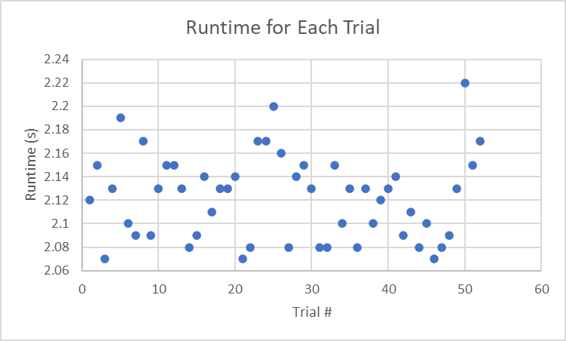

The graph shows that the minimum runtime was 2.07 seconds and the maximum was 2.22 seconds, with an average of 2.1225 seconds. This time was less than half of the required time layed out in the design requirements.

The second, and more important, metric to test for was accuracy. These tests were conducted by running full decks, organized Ace through King for each of the 4 suits, and ran 1 card after another and recorded the value in a truth table. This test was conducted 20 times and a confusion matrix was produced as shown below.

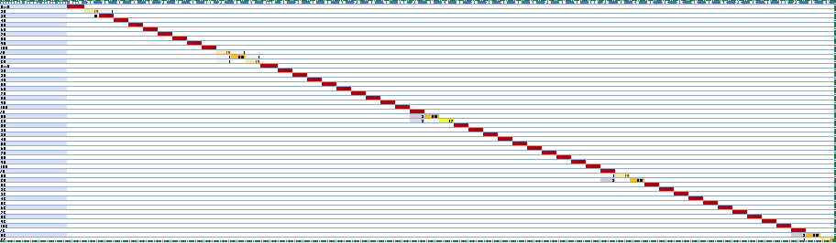

The matrix has the expected values, numbered 1-52, as the columns, and the actual reported values as the rows. The dark red represents 20/20, light yellow represents 19/20, orange represents 18/20, dark yellow represents 17/20, steel grey represents 3/20, grey represents 2/20, light grey represents 1/20, and white represents 0/20.

After running the 20 tests, there were 1040 cards tested, and 1024 were correct and 16 were incorrect. This produces an accuracy of 98.5%, which is right below the required 99% accuracy. However, 15 of the 16 misreads were face cards, meaning that the point values were still accurate. The tests produced a 1039/1040, or a 99.9% accuracy, for the point values for the cards. This demonstrates that the algorithm meets the design requirements for both accuracy and runtime.

Additionally, the suit of every single card was accurately identified. This held true for all trials, even the ones not included in the final tests. The suit identifier can confidently be labeled as 100%, even though the suit is not required for blackjack.

### Hardware Systems

#### Power Supply

The first test was for an AC-DC output voltage ripple of less than 2%. This test was performed by using an oscilloscope with AC coupling to determine the level of the AC signal present in the DC signal, and then dividing that by the DC level at the output. The results of the test are shown below:

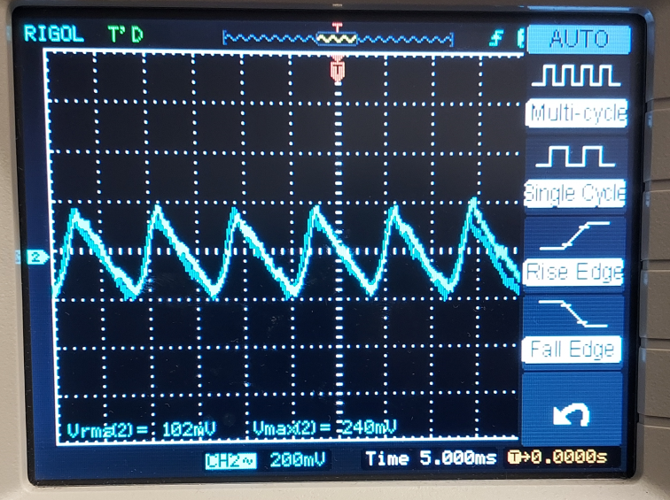

Figure 30: Output ripple of power supply

The results indicated that our output voltage ripple was around 240mV. that equates to around 1.2% of our 20V output; well below the target value for our power supply and within the realm of industry standards (Less than around 3%-5%).

Another test for the project would be to determine the transient response of the circuit. This was done by viewing the voltage across the motors at steady state though an oscilloscope, running the motors at the speed of an expected movement, and viewing the transient that occurs. Below is a sample of the final results of these tests:

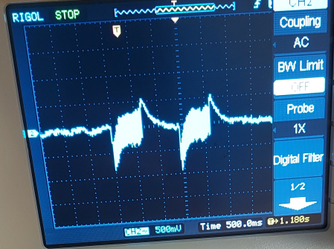

Figure 31: Transient response of motors on power supply

This response indicates that for about 50ms, the supply voltage shoots down dramatically for a moment before quickly righting itself while the motor is in operation. This is indicative of the high starting current of the motors causing a corresponding decrease in the voltage. Once the brief spike in current passes, the motor then causes a series of alternating transients before settling down. These sharp changes in the transient is likely due to the rapidly changing torque being applied by the motor, as while in operation on the gantry, the tension applied on the motors by the straps changes based on where the movement arm is. These were all aspects of the transients that were expected in our estimations, and likely did not contribute to any abnormalities in other aspects of the circuit.

A series of smaller tests were performed to ensure that all aspects of the circuit were being supplied with their rated voltages and currents. Below are the results of these tests:

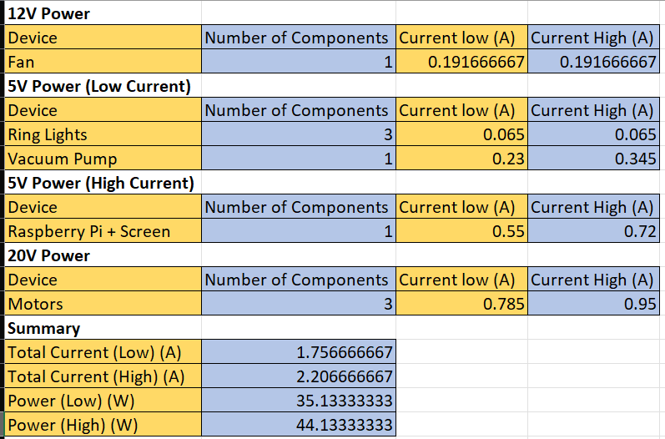

Figure 32: Voltage and currents throughout the fully integrated system.

The results of these tests were expected, as all voltages in the system were within the expected ranges for each device in the system, while all currents were consistently at or below rated draw. The overall output power high came to be around 44W, well below the 150VA that our transformer could supply.

#### Gantry System

The physical requirements described in section 3.1.1 were primarily a function of the primary mechanism and gantry design. The tests performed for each requirement are discussed below.

1. 3.1.1.1 Dimensions:

All dimensional requirements were met, it is able to fit on a tabletop and also capable of accommodating three players at a time. There was plenty of clearance for the gantry, ~8”. In addition, the camera was 10” from the acrylic and the playing surface height was 11”. Overall dimensions (X x Y x Z) were 520mm x 520mm x 500mm (approx. 20.5” x 20.5” x 19.5”).

1. 3.1.1.2 Card Movement:

Testing card movement was of two parts.

One, the repeatability of movements to each player. A file was written to stream commands to place 5 cards at each card position–player 1 card 1 and 2, player 2 card 1 and 2, etc. This was written and performed using the functions of the Move() object just like in game. The main concern is maximum error over repeated movements, so I only recorded the largest error between any two cards dealt to the same location. Additionally, measurements were recorded as less than ⅛” or less than ¼” as that was the greatest amount of error I found and well within tolerances.

| Player (1,2,3,D) | Card | Max Error |
| --- | --- | --- |
| 1 | 1 | <⅛” |
| 1 | 2 | <⅛” |
| 2 | 1 | <⅛” |
| 2 | 2 | <¼” |
| 3 | 1 | <⅛” |
| 3 | 2 | <⅛” |
| D | 1 | <⅛” |
| D | 2 | <¼” |

Table 3: Card movement error

Second, five games were played in sequence and after each initial deal, the position of each card relative to the ideal placement was observed. For this test, tolerance boxes were marked around the cards dealt in game one for comparison to the subsequent games. Originally, this was difficult to test due to vacuum tube twisting, but I was able to eliminate most of that by changing the card drop sequence. Even so, every dozen or so moves a card would twist by approximately 3 degrees. Ignoring that complication, every card was placed within the drawn boxes.

1. 3.1.1.3 Speed and Timing:

The time to complete a deal was measured for one, two and three player games respectively. The recorded number of players reflects the dealer plus the other hands dealt.

| Trial | Players | Deal Time |
| --- | --- | --- |
| 1 | 2 | 2:11** |
| 2 | 2 | 1:57 |
| 3 | 2 | 1:59 |
| 4 | 3 | 2:54 |
| 5 | 4 | 4:00 |

Table 4: Timing test results

**This time was collected prior to optimizations made that reduced other trial times.

1. 3.1.1.4 Vacuum Generation:

Prior to integration, vacuum was tested by proving it was capable of picking up a card. Once this was confirmed, the vacuum pump was connected to a suction cup through tubing. Using this setup, cards were manually picked up and agitated to try to make a card fall off. This was repeated dozens of times throughout testing without any failures. Next, the vacuum setup was integrated with the gantry, and the ability to maintain hold of a card at maximum velocity was tested and successful. After integration into the gantry, hundreds of runs and trials were performed, the vacuum tube never failed to pick up a card and never dropped a card during a move.

# New Skills and Learning Strategies

## Kyle Cullen

Over the course of this project, I learned a lot about prototyping. Particularly as I was iterating over a highly mechanical design, and there is a very short period of time for completion, I needed to find quick solutions to implement and test. If my design was too reliant on 3D printed parts, we would have been reliant on the 3D printers, which became a clear issue in the end for some teams. Instead I became much more familiar with aluminum sheets as a quick and dirty fix to hold and position bearings, act as mounting supports, block overhead light for the camera, etc. This was critical at multiple points when I was able to save a day or two from designing, printing, and checking a 3D printed solution (or having Nicholas do it), instead I could, with a drill and a pair of pliers, have a reasonable solution in ten minutes.

This was a great learning experience, and I used every avenue available to improve this skill. From sitting with Nicholas and designing parts, cutting away unnecessary bits to reduce printing times. Too using my dad’s experience and working in his shop, using him as a sounding board for issues and their solutions. Constantly needing new solutions also led me to use the internet differently. I couldn’t just look up a particular part, because either I wasn’t sure it existed or, if it did, I wouldn’t know what it was called. Instead I was forced to analyze other designs on YouTube, or parts on Thingiverse, and consider how I could change them into something to fit my needs.

Perhaps I’ll never use this skill in exactly this way again, but I think it is translatable, and I will likely use some of the ideas and principles in the future as a project engineer.

## Nicholas Lowe

One of the most impactful skills I refined throughout this project was the ability to analyze systems and troubleshoot problems using past concepts and engineering principles. Multiple times throughout the project, I came across data or results that I had to reason through to come to a greater understanding. One such example was the motor transients shown in the test section. For a long time, I had to sit down and determine what aspects of motor operation (and thus physics) were at play and come to an understanding that explained the phenomenon that occurred. I feel like understanding these results and becoming more inquisitive about them really lent to my personal growth as an electrical engineer.

## Curtis Maher

Some skills that I heavily refined through working on this project are developing a code repository through Git and with a team, as well as learning new softwares and platforms “on-the-fly.”

I have had experience in the past working on software development projects with Git and Github both by myself and on a team. One of the key features that I previously never had great practice with was handling several different branches from a functioning master and resolving the merge conflicts that may come with it as pieces are steadily integrated. In a scenario where I could handle and resolve this myself, that would be much easier, but it proved challenging and rewarding to have that experience in a team project with multiple people developing software in different ways and for different modules.

As a computer engineer, working with new softwares and understanding existing code that somebody else wrote is always something I’ve had experience with. However in this project, I was able to push that to the furthest extent when understanding Kivy, the GUI library I chose to use for this project. At any one time, I had opened several tabs of the Kivy source code documentation to understand how its objects functioned. I also had to heavily research various issues I would encounter and see if others across the internet found resolutions to them. Doing all of this enabled me to build the UI to the best of my ability and quickly figure out issues such as the inability to auto-transition screens due to the idle loop functionality.

## Luca Mahoney

This project presented me with a significant amount of learning in order to complete my module. I was tasked with spear heading the computer vision and image processing module, yet I did not take any courses on computer vision or machine learning. I had plenty of Python experience, so I wanted to find a way to solve the problem of identifying cards using Python.

In order to learn what computer vision is and how it works, I communicated with Dr. Ahmed Dallal to find out what resources I was going to need. He recommended taking some online crash courses, so I took the OpenCV for Python Developers course on LinkedIn Learning [18]. From this course, I learned the basics on how image processing works, and how images can be identified from a larger image. It also taught me how to draw contours and how to properly retrieve the area and perimeter from each contour I drew.

This online course propelled me into being able to successfully complete my module. I directly used the methods taught in this course to apply Gaussian blurring and graying to my images, and to properly use adaptive thresholding and contour drawing to pull different shapes from each playing card. The course also taught me how to retrieve the area and perimeter of each contour. I used this knowledge to develop my algorithm, which would run several filters on the full list of contours received, to filter out contours that matched a size range for each of the valid shapes. This allowed me to write a predictive algorithm based off of the sizes of the shapes that passed through the filters. Without this crash course, I would not have been able to understand OpenCV or apply basic image processing methods to playing cards and our direct product. Once I had a solid understanding of the mechanics of all of the methods, I was able to apply my engineering principles and good coding habits to properly solve my module.

# Conclusions and Future Work

### Planned Minimum Design

At minimum, our design was to be capable of completing a game of blackjack against one player–less than 3 minutes to deal–and only some of the automated features. The design needed to be implemented without the feature of betting, simply determining if the user won or lost. The minimum design would also have been implemented without a flipping mechanism. Instead, the user would simply flip the cards themselves as necessary within bounds marked on the playing surface. The minimum image processing design would have only retrieved the value of each card, instead of both the value and the suit.

### Actual Design

We were able to successfully implement a design that is capable of three player blackjack games. It is also capable of performing all the functions that would be expected at a blackjack table–splitting, doubling down, etc–and tracking bets. Dealing metrics were a minute under design goals for all player amounts. Finally, the image processing module identified both value and suit, including distinguishing between face cards.

### Improvements and Design Changes

### Two major limitations of the current design is the lack of flipping and speed. If it weren’t due to a significant hardware failure in the last week, we think flipping would be fully functional. It wouldn’t be exceptionally complex to institute as we had planned with a relay circuit or, preferably, by changing the Arduino code to support four motors instead of three. On the speed side, we believe there were reasonable optimizations within reach, but again time constraints didn’t allow time for enough testing to truly implement.

In retrospect, the structural design would have been executed differently. It was unnecessary to reinvent a coreXY gantry design from scratch. There are numerous open source builds that could have been utilized. Any of these could have eliminated much of the time spent mechanically troubleshooting and optimizing the gantry design and motion. Additionally, a larger playing surface would have allowed us more room to add both software and hardware features, such as additional players, additional decks, and/or alternative movement/flipping mechanisms.

For the game logic, it would have been nice to add more features and clean up the UI. The ability to place insurance bets, deposit more credits, and add and remove players all would have been features the would enhance our system, but the implementation for each was held back due to indecisiveness of how to visually design them as well as worry that their implementation may be a detriment to other parts of the software or system as a whole.

For the computer vision module, a future design that uses TensorFlow to make the predictive algorithm more accurate would be interesting to explore. The module that was designed is specific to the exact sizing of the prototype and requires perfect lighting. It would be interesting to explore if using machine learning would be able to solve this issue in either a more accurate or more efficient manner.

# References

[1] Miller, A. (2021, December 17). How does a casino make money from Blackjack? Retrieved from Gamle Online: https://www.gambleonline.co/blog/how-does-a-casino-make-money-from-blackjack/#:~:text=So%20a%20casino%20would%20expect,your%20%24100%20bet%20on%20average

[2] ZipRecruiter. (N/A, N/A N/A). What is the Average Casino Dealer Salary by State. Retrieved from ZipRecruiter web site: https://www.ziprecruiter.com/Salaries/What-Is-the-Average-Casino-Dealer-Salary-by-State

[3] Golden Acorn Casino. (2018, October 29). Casino Tipping Etiquette Guide. Retrieved from Golden Acorn Casino Travel Center web site: <https://www.goldenacorncasino.com/blog/gaming/casino-tipping-etiquette-guide/#:~:text=In%20general%2C%20you%20should%20expect,for%20a%20particularly%20long%20time>

[4] PA Department of Labor and Industry. (2022, N/A N/A). General Wage and Hour Questions. Retrieved from PA Department of Labor and Industry web site: <https://www.dli.pa.gov/Individuals/Labor-Management-Relations/llc/Pages/Wage-FAQs.aspx>

[5] Krog, K. (2022, September 1). Playing Online Blackjack at Live Casinos: A Comprehensive Guide. Retrieved from Betters Insider: <https://www.bettorsinsider.com/casino/2022/09/01/playing-online-blackjack-at-live-casinos-a-comprehensive-guide>

[6] Sztein, A. (2013, February 24). This Robot Dealer Can Read Cards and Won't Hit on 21. Retrieved from TrendHunter: <https://www.trendhunter.com/trends/robot-dealer>

[7] Motoman Robots. Robots Done Right. (n.d.). Retrieved September 30, 2022, from https://robotsdoneright.com/Motoman-robots.html

[8] Penn National Gaming, Inc. (2021, September 29). Blackjack Rules and Guidelines. Retrieved from Hollywood Meadows: <https://www.hollywoodmeadows.com/-/media/png/east/meadows/pdfs/table-games/gamingguiderebrands2022/mdpb-apr22-gaming-guide-rebrand-file-resend-digital-col-84418-blackjack-min.pdf>

[9] Federal Communications Commisison. (N/A, N/A N/A). Equipment Authorization-RF Device. Retrieved from FCC: <https://www.fcc.gov/oet/ea/rfdevice#:~:text=The%20FCC%20regulates%20radio%20frequency,9%20kHz%20to%203000%20GHz>

[10] Ocupational Safety and Health Administration. (2008, October 29). By Standard Number/1910.303-General. Retrieved from OSHA web site: <https://www.osha.gov/laws-regs/regulations/standardnumber/1910/1910.303>

[11] Hammond Manufacturing. (N/A, N/A N/A). Low Voltage, Filament High Current, Chassis Mount - 125 VA to 440 VA. Retrieved from Hammond Manufacturing web site: <https://www.hammfg.com/electronics/transformers/power/165>

[12] Vasquez, J. (2014, May N/A). CoreXY. Retrieved from Double Jump Electric web site: <http://www.doublejumpelectric.com/projects/core_xy/2014-07-15-core_xy/>

[13] Rani, U. (2020, August 19). Ripple Factor of L-section Filter. Retrieved from Youtube web site: <https://www.youtube.com/watch?v=wDdHWcPHm6A>

[14] N/A. (n.d.). AcetoFive. Wikimedia.org. N/A, N/A.

[15] Dejan. (N/A, N/A N/A). G-code Explained | List of Most Important G-code Commands. Retrieved from How to Mechatronics Website: <https://howtomechatronics.com/tutorials/g-code-explained-list-of-most-important-g-code-commands/>

[16] C-BEAM® linear actuator bundle. OpenBuilds Part Store. (n.d.). Retrieved September 30, 2022, from https://openbuildspartstore.com/c-beam-linear-actuator-bundle/?sku=995-Bundle&amp;gclid=CjwKCAjwp9qZBhBkEiwAsYFsbzN56A5mzjgf9VDrDf03D2nTnK0K0kWv7D2KgLrUDnmbTf_ar4hY_hoCkW8QAvD_BwE

[17] Kivy, open-source user interface software library. https://kivy.org/doc/stable/

[18] OpenCV for python developers online class: Linkedin learning, formerly Lynda.com. LinkedIn. (n.d.). Retrieved December 16, 2022, from https://www.linkedin.com/learning/opencv-for-python-developers